Addingham Parish Council Meeting
19th February 2020

For Information

Zero Waste Addingham
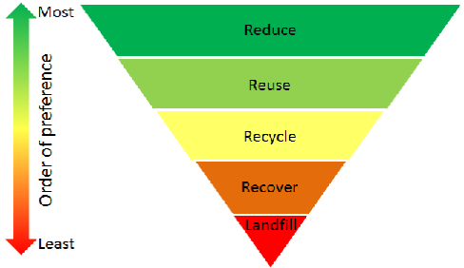
The work of the Addingham Environment Group on waste is gathering momentum. On February 27th, The Civic Society speaker meeting will be hosted by the Zero Waste Group with the title: “How Green is our Village, Part 3: War on Waste”. Dave Johnston and Ian Benson will make a slide presentation on “Zero waste Addingham” and Edith Grooby, Bradford’s Waste and Recycling Manager, will attend to take part in the discussion and answer questions.
To help raise awareness and pass on information Dave and Ian are offering to keep updating their presentation and talk to other clubs and societies in the village.
Then in March, the zero waste group will be taking over the display space in the Hub to showcase the initiatives being taken and being planned in the village to reduce waste. These include:
- The work of the Primary School guided by class teacher Jake Duxbury to become “plastic free” under the Surfers against Sewage plastic-free school programme;

- Water Refill points There are now six refill points for personal water bottles in the village, The Swan, The Craven Heifer, Hamiltons, the Ginger Plum, the Sandwich Shop and the Fleece. Sam Makin is our local champion;

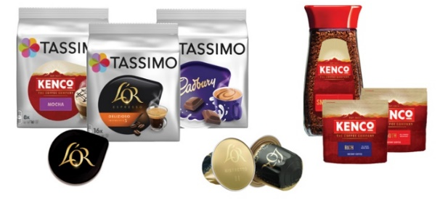
- Terracycle is an international project designed to recycle the "non-recyclable" such as coffee capsules, crisp packets and toothpaste tubes. The Scouts have set up a crisp packet recycling scheme (https://www.terracycle.com/en-GB/brigades/crisppacket), there’s a yellow wheelie-bin next to the Scout Pavilion, and we have started a Tassimo and L’Or coffee pod re-cycling scheme (https://www.terracycle.com/en-GB/brigades/tassimo-lor) at the monthly Civic Society meetings.
- Plastic free retailing Many retailers are doing their best to avoid single-use plastic in their businesses, but some, especially supermarkets, have a long way to go. Surfers Against Sewage is encouraging ‘Mass Unwrap’ events across the country between Sat 22 Feb and Sun 1 March 2020 to draw attention to plastic packaging at supermarkets (see: https://www.sas.org.uk/organise-a-mass-unwrap/). The Group is holding a “Mass unwrap” event with our local Co-op between 10:00 and noon on February 29th ;

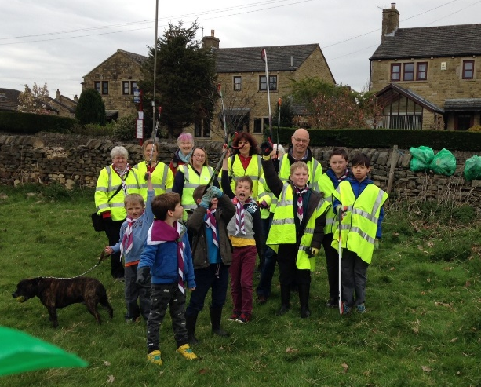
- Addingham Spring Clean. We are planning to hold our annual village litter pick on Saturday 21st March. As in previous years we are hoping it will involve the Scouts and Cubs. Our regular AEG Litter Pick Wardens will lead small groups scouring all our village green spaces and there will be a general call to all our members to pick litter in the street close to their front doors. Gloves, litter pickers and bin bags will be provided as usual by Bradford Council;
- Pop-up shop Following the very successful “Waste-not Shop” in Burley set up by Charlotte Hawkins we’re hoping to do something similar in Addingham. We’re delighted that Jane Tapper of the Plantation in the Main St. will be selling a small range of cleaning products from refill containers. These are washing up liquid, laundry liquid, fabric conditioner, hand soap, shower gel/bubble bath, and shampoo. To keep things manageable, they will be sold in 2 quantities: 500 ml and 1 litre. It is planned to start this in March with the ‘pop up’ being open on Tuesday mornings and Saturday mornings.

- Table top trail sale Before recycling comes re-using (see diagram)! Instead of scrapping unwanted household items we are proposing to offer them for re-use by holding an annual table-top village trail sale. Put useful but unwanted items out in front of your house and/or walk around the village picking up bargains….. It’s likely to be on a Saturday in the summer;

- Food Waste. At some stage it might become mandatory for Councils to collect food waste but at the moment Bradford do not have any plans to do so. Instead they encourage composting at home. We are exploring the possibility of introducing a community composting scheme which might be especially valuable for residents who do not have space to do home composting.

Addingham Environment Group
February 2020

