THE ADDINGHAM ARCHIVE OF HISTORIC PHOTOGRAPHS
Making the Archive accessible

OVERVIEW

Across the past 20 years, Don Barrett has worked with members of the Addingham community to gather historic photographs of the village and make them accessible to everyone. This effort was given a boost as part of the grant-funded project to renovate the Old School as a library, information hub and heritage centre, and has now gathered steam and is being formalised with the creation of an Archive team within the Heritage Group of the Addingham Civic Society.

It is proposed that the Civic Society’s work will proceed hand-in-hand with the project currently being established by the Parish Council to develop a separate digitised searchable archive of historic and legal documents, the originals of which are held by the Council and on deposit by the West Yorkshire Archive Service (WYAS).

The Civic Society archiving team is now requesting funds from the Addingham Parish Council to make the images held in the photo archive accessible online to all, using iBase software. These funds are part of the grant monies which the Parish Council and Library received to remodel the Old School.

The Addingham Civic Society will manage the effort going forward, funding its needs –other than this one time purchase of iBase--including insuring against liability.

Recommendation: An iBase cataloguing system should be purchased at a cost of £4,950 from the grant funds related to the Hub remodelling.

ARCHIVE BACKGROUND AND CONTENTS

The Archive of historic photographs began in the 1960s when the late Hilda Holmes began collecting and making copies of old photographs, some of which dated back to the 1880s. At the same time, she began photographing and documenting the village herself. She put all of this on to 35mm slides for use in slide shows at Civic Society and other meetings. Before her death, she passed this collection to Kate Mason who continued in the same way and added her own photos.

Following Kate’s death in 2006 her family passed her combined archive collection, plus access to family photographs etc, to Don Barrett, on behalf of the Civic Society, with the aim that they be made publicly available. In the meantime, since moving to Addingham in 1995, Don had also been photographing the village and village events, including making video and audio recordings, and collecting more photos and other items from various sources, including David Pratt, Arnold Pacey and David Harrison.

As a result of all the above, Don now holds a collection of over 14,000 digital files related to Addingham and all the original slides and photographs etc. as above which total about 5,000 items/images. See Appendix 1.

In 2010 a selection of about 1600 images in the archive was put online in a Flickr account by Don Barrett for online access but there are limitations to using Flickr: for example, searching is limited, IPTC metadata is not shown, and non-image files cannot be included.

There has been a lot interest in Addingham Archive photos when slide shows have been given at club meetings and public events. In addition, to date there have been 21,730 recorded image views of the Flickr site and it is therefore very important that the archive be safeguarded for the future and made much more accessible. This requires a proper on-line catalogue system which will enable archive images to be easily accessed online with a powerful search facility to enable all images relating to any subject to be shown.

Discussions that began with the remodelling of the Addingham Old School have evolved into the creation of an Addingham Archive team that is set up within the Addingham Civic Society’s Heritage Group who will oversee the effort.

COMPLEMENTARY PROJECT TO DIGITISE PARISH RECORDS
Concurrent with this effort by the ACS Archive Team to catalogue and display its archive items, Addingham Parish Council is undertaking a separate and related exercise to digitise a large number of documents in its possession and on deposit at the WYAS, so as to provide an online searchable records archive. Although these two projects are separate, there will be much learning to share during the archiving work that will improve the quality of each archive. Ultimately it is likely any research into local topics will be enriched by cross referencing items in each archive, along with other regional sources of material, and in making both sets of digitised records available to be accessed from both the PC and Civic Society websites.

PROJECT PLAN HIGHLIGHTS

Organising Items in the Archive:
- Create list of physical items - complete
- Assess ownership of items – 90% complete
- Create plan to obtain Creative Commons licenses – Don Barrett to implement
- Scanning of physical items – 60% complete
- Plan to safely store physical items – To be determined by ACS
- Assess items that should receive permanent display containers for shows and events

Back up and Archive Team Work Folders:
- Create offsite back-up storage plan

Cataloguing & Uploading Images:
- Catalogued and Uploaded – 1900 items so far
- Planned 5000 Items Catalogued and Uploaded by April 2020

MANAGEMENT OF THE ARCHIVE

The Archive Team is part of the Heritage Group of the Addingham Civic Society and its efforts will be managed as part of their established structure and procedures for subcommittees. The ACS is overseen by trustees who review the progress and finances of the subcommittees through regular reports and meetings.

Ongoing Funding
The ACS will support the Archive Team financially and assure that their efforts are successful. Additionally, the ACS holds liability insurance to cover all of its activities, including the Archive Team’s efforts.

Succession Planning
Succession planning for the Archive Team will follow the procedures that all ACS committees follow, assuring the long term viability of the Addingham Archive.

Licensing
A plan to procure Creative Commons licenses for the archive items will be created. Don expects that licenses for most of the items will be forthcoming based on his conversations with the largest contributors’ estates (family members).

Not all contributors or their estates are contactable, given the age of some items. As the images in the Archive are not being used for commercial purposes, there should be no liability issues. However, the Team will take down any image as requested by someone showing ownership. Finally, the ACS holds liability insurance for the unlikely situation where a copyright dispute arises.

A summary of the items in the Archive can be found in Appendix 2.

Display
Certain physical items will be interesting for periodical exhibitions and events in the Hub or taken to village events, but will need proper archival containers. To be assessed, funded and managed by the ACS.

Storage
The remainder of items need to be stored in an archival vault of some type. To be assessed and any funding to be overseen by the ACS.

Current Status

About 1300 items have been designated “5 Star” as items that are likely to be of most interest to the general population. These have been prioritised and as of now, 1000 of these 1300 images have already been catalogued and uploaded to an internal version of the iBase system. In addition, another 900 items are already in the iBase system.

The remaining items will be uploaded as they are catalogued. The team has a goal of 5000 images on iBase by April 2020.

CATALOGUING SYSTEM

Decision Process

To properly manage the items for online search and display, a dedicated cataloguing and hosting service is needed that is designed for management of digital assets.

After researching the situation, the team narrowed it down to two options:

Community Sites - https://www.communitysites.co.uk
iBase - https://www.ibase.com

Both companies have a client list that demonstrates they have expertise in meeting similar needs to those of the Addingham archive however the Heritage Group archive team favour the iBase proposal for the following reasons:
- The uploading procedure is much better in that the metadata is automatically extracted from the files to the catalogue whereas the Community Sites system requires that the metadata be extracted to a spreadsheet as a .csv file and then imported, giving considerable risk of errors and taking longer.
- Cost – iBase have made us a special offer which is for a one-off charge of £4,950 for set up, training and 10 years hosting with up to 50Gb storage. This capacity is considered adequate for the likely growth of the archive over that period. The Community Sites quote totals £6,895 for 10 years with the same storage and training etc. This includes annual maintenance and hosting charges for the 10 years.
- iBase are a local firm based in Ilkley and we already have a good relationship with the principle (the founder lives in Addingham). Their system is used by the Bradford Photographic Archive based at the Industrial Museum and is known to the curator of the Bradford Media Museum (both of which have been visited by volunteers and councillors). Community Sites is based in Hove, Sussex.

Additional Information
iBase will host the catalogue for 10 years for a one-off payment of £4,950 + VAT.

This includes:
- 50GB of storage
- Storage is cloud-based through AWS (Amazon Web Services) in London
- AWS holds the assets (images+data) securely on our behalf
- Design of branding/logo/colour scheme
- 4 hours of training
- Upgrades – normally about one per year

iBase chargeable work (£165/hour + VAT)
- Data migration to/from another server if needed
- Changes to site design
- Adding functionality (e.g. a payment system)

In 2029, iBase can continue to host it under a new contract. Should ACS decide to change providers, the images+data can be exported to another server. Should iBase cease to trade, the data can be downloaded from AWS since it is not part of the iBase assets.

Recommendation: iBase cataloguing system should be purchased at a cost of £4,950.

HARDWARE

A digital copy of all items in the Archive will be uploaded to a ACS-owned server, TBD. This will be a mirror of a Cloud work area where the Archive Team members will edit and improve the embedded metadata of each image before uploading to the iBase system where it can be accessed and viewed by external users.

CATALOGUING & UPLOADING

There are currently 8 volunteer members of the Archive Team who are working to catalogue the images and upload them. The Team bases their efforts on the Dublin Core system, which is an internationally recognised system and is used by Bradford Museums. iBase also uses the Dublin Core system.

The process the Team follows is shown in Appendix 3. In short:
- The Team member logs in from his home computer
- The “5 Star” images are separated into a folder to be catalogued first
- These images are uploaded to the iBase system
- Each image is opened in iBase and details added: Title, Source, Creator, Description, Keywords, Notes, Location (geolocation if possible)
- Additional fields can be added in the future

USER EXPERIENCE

The Archive’s URL will be: archive.addingham.info

Links to this URL will be available from:
- www.addingham.info - run by Don Barrett, owned by Addingham Civic Society
- www.addinghamcivicsociety.co.uk – owned by the Addingham Civic Society
- www.addingham-pc.gov.uk – owned by the Addingham Parish Council
Other relevant sites will also be encouraged to link to it

Once on the site, users can browse the images or, if they have specific interests, they can enter search terms.

Present catalogue format:

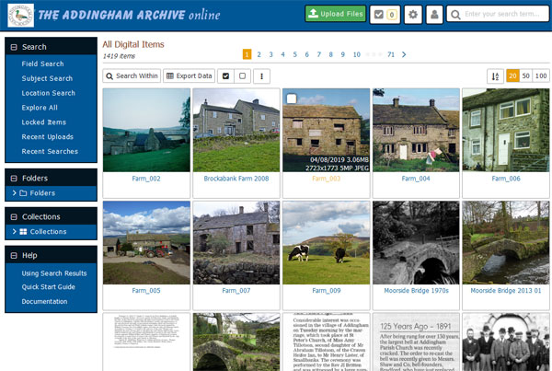

COMMUNITY OUTREACH

The ACS and the Archive Team aim to publicise the Archive as widely as possible to the Addingham community so that it can be enjoyed by as many people as possible. The Parish Council will also be publicising the development of the records archive project, and, again, the two projects will assist and complement each other. An initial online survey, currently open to the public, is designed to gauge community interest and feedback on proposals to develop both archive projects. The results will be used by the Parish Council and Library to attract further grant funds for the benefit of the village heritage projects.

A primary side goal of this is to “crowdsource” additional information about the background of the images in the Archive and the Parish Council and WYAS records. Many residents will have stories and memories of the history of certain images and documents. A resident can provide this information to the team and/or to the Parish Council. Both bodies will share information as appropriate, and the Civic Society, working already on cataloguing the photo archive, will ensure it is uploaded into the metadata of the image itself. The team can be contacted by the following methods:
- The iBase system provides a button to contact the team
- Directly emailing archive@addinghamcivicsociety.co.uk
The Parish Council can be contacted by emailing the Clerk. Both bodies can be contacted by:
- Attending various drop-in events where the Archive projects are being presented

Longer and more detailed stories could be recorded as transcripts or audio files are linked to the photo images and documents. This will be explored further as the situations arise.

The Archive Team aims to publicise the Archive through:
- Civic Society Newsletter & Website
- Village website and Facebook page
- Parish Council Newsletter & Website
- School Newsletter
- Various community websites and social media
- Local newspapers
- Civic Voice (the national charity for the civic movement in England)
- Etc.

Appendix 1 – Physical Items in the Archive

The screenshots below show the items in the physical items in the Archive. The actual spreadsheet of items can be provided if desired.

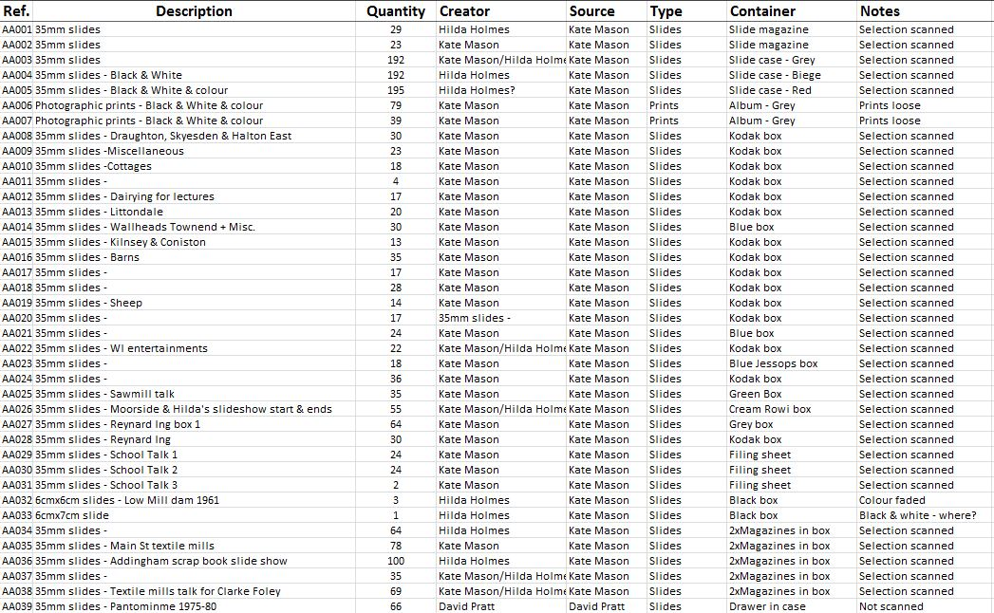

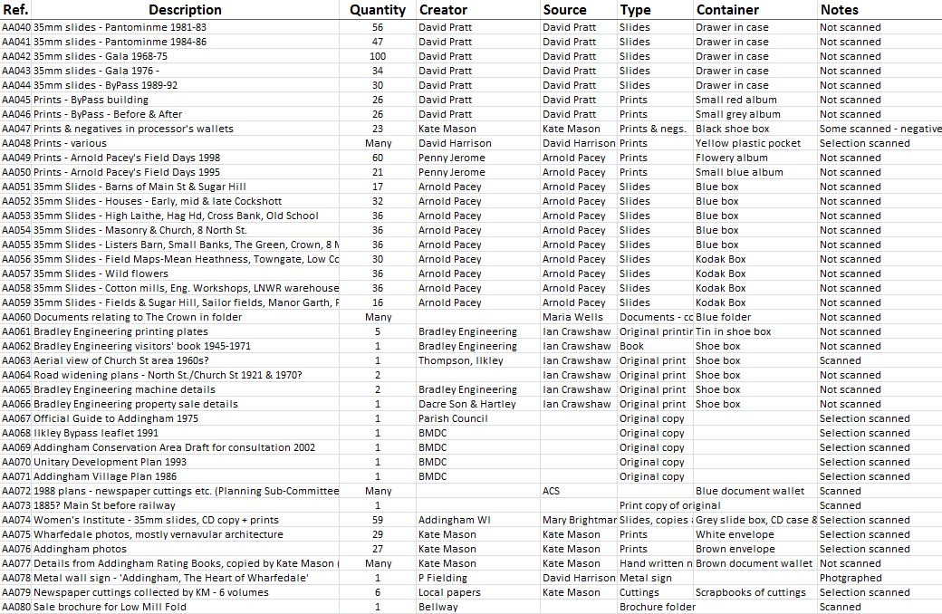
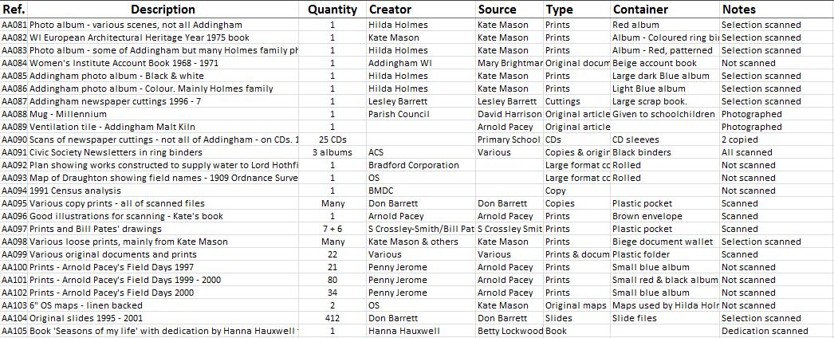

Appendix 2 – Archive Material Consent Form

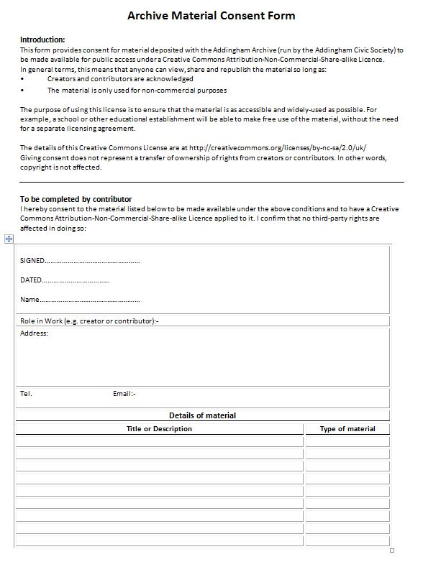

Appendix 3 – Archive Editing Procedure

Aim: To select what we consider the files which will be of most interest to the public and make these available on the iBase catalogue.
Note: It is expected that there will be two basic types of people looking at the archive – people who are interested in a particular thing or others who just want to browse to see what there is and what might interest them. To suit the latter, the ‘front page’ should show only those of most interest to most visitors but with sufficient detail to satisfy most of the former. To satisfy researchers and those who want maximum detail, all the archive files (including near-duplicates etc.) will be made available through the cloud storage or possibly via restricted iBase folders (logon required) if there is room.
Procedure:
- I will continue to send each editor a folder or selection of files (roughly 100 at a time) via Dropbox.
The first stage is to sort out the ‘Favourite’ or ‘5 Star’ files which will be accessible via the catalogue and these should be separated into a sub-folder which you will need to make in Dropbox (labelled ‘folder name 5 Star’) prior to uploading the files to iBase as below.
The files could be viewed in Windows File Explorer (or equivalent on a Mac) or a photo editor, to make selection easier. You now have to make a decision on which to choose. This might be because of historical interest, that it might show how the village is changing, might show people now and from the past that would be of interest to family, friends or researchers. They should include at least one photo of each building, where available, plus additional ones (if necessary) showing the surroundings and changes over time. Also, show events (e.g. Blue Plaque unveilings) and include newspaper cuttings where these add information. If in doubt do select it because we should have plenty of space.
It is obviously a subjective decision but you will become more expert as you do more archiving.
The selected files now need to be uploaded to iBase.
Do this by opening and logging on to iBase and then opening the appropriate catalogue folder from the drop-down list on the left (I will set up appropriate folders e.g ‘Mills>Townhead’ or ‘Streets<Back Beck Lane’). Click on ‘Upload files’, select all the files in your ‘5Star’ sub-folder in Dropbox and drag them onto the upload panel – uploading will start immediately. To work on images, you need to ‘Open folder’ which allows you to edit images as below.
- The folder panel will now show the thumbnails across the page and the next stage is to edit the metadata. Opening a file will show the existing metadata automatically – to edit this click ‘Edit Item’ at the top to show the editable fields, which are sub-divided by tabs – we will use the following:
‘File Details>Title’ – add a brief but descriptive title. This will appear under the thumbnails and above the image on left.
‘File Details>Source’ – if this is known
‘Other Details>Creator’ – The photographer or author, if known
‘Description’ – A description of the image with as much detail as possible. This is a very important field.
‘Keywords’ - This box may be empty or already contain keywords from previous archivists. Entry of keywords facilitates searches in finding particular images. So, if they were to be looking for pictures relating to the Saw Mill, they would search on the keyword/s Saw Mill, and quickly locate them. You can choose to leave the keywords as you find them, remove ones that are inaccurate and add your own that you might feel are relevant – the more the better. You add keywords by typing them into the box below the Keywords tab – they should be separated by a semi-colon and a space. If at all possible, please add a date as a keyword, again to facilitate searches. We only want a decade added. For example, an old photograph from 1892, would be entered as 1890s, one taken in 2009 would be 2000s.
‘Notes’ – This space is mainly of use for audio/video files etc. which do not store metadata. Add as much detail as possible.
‘Location’ – if a location exists it will be shown on the map below the image (you may need to click ‘+Geolocation Data’). To add a location, click Add Location and drag the pin from the equator to the location in Addingham.
Note: Below the map is ‘View all items at this location’ which shows them as a photo or a coloured number where there are more than one.
- There are many other tabs such as Labels, Subjects, Collections and Links but we will leave these for now and ignore the other fields.
- When you have finished editing click ‘Update Item’.
- When you have finished your batch, please let me know.

General Notes:
- Hint Cards may appear above or below each tab. It’s worth reading these but if cancelled using the X in the corner they should not re-appear. The Quick Start Guide is helpful but the full documentation is heavy going!
- Selecting & Batch editing – select files by hovering and clicking the square at top left or select all using the black tick box at the top. Selected files will appear in the ‘Selections’ panel across the bottom. Note that selecting-all only applies to the visible thumbnails, maximum 100 per page. If you have more than one page repeat for the next page(s) – they will be added to the selections panel and the total number selected will be shown beside the word ‘Selections’.
The Selections panel gives various options including moving and batch editing - note that the tabs are active (i.e. clickable) when they turn orange.
- Batch Editing - to batch edit, hover over ‘Batch Edit’ (it will turn orange) and click on it to bring up the list of editing options. The drop-down options under Batch Edit will rarely be needed. Batch editing will affect all the files showing in the Selections panel so make sure there are no other files selected.
They can be removed by hovering over the thumbnail and clicking the ‘-‘ sign in the corner.
If you want to Add to the existing (e.g. Keywords) use the Append option but note that Keywords require a semi-colon and space.
- Deleting - If you delete something it is only fully deleted when you ‘Empty the trash’ – you can do this once and all deleted images held in trash will go, there is no need to do it every time – if they are left this acts as a back-up and it can be emptied later. Note that the folder will still show a ‘ghost’ image that will disappear when you move to a different folder. Note that, oddly, the Trash box is hidden under the ‘Workflow’ tab.

