Addingham Civic Society Environment Group
Update for the Parish Council Meeting on Wednesday 20 November 2019
Hoffman Wood Field, Memorial Recreation Ground & Gala Field and New Sites
For information and discussion
Hoffman Wood Field- Wildlife Margins
- The grass margins were cut by Bradford MDC in September as requested.
- AEG volunteers raked off the grass, and BMDC collected the piles.
- On the bank next to Church Street, AEG volunteers have planted wildflower plug plants and transplants, and sown patches of yellow rattle (a useful plant which helps to supress the dominant grasses).
- The Woodland Trust Hedge Pack for the new hedgerow on the eastern boundary has been ordered and will be delivered in March. In the meantime, in late November/early December, we will start planting some of the hedge with our existing stock of plants.

Memorial Recreation Ground & Gala Field

- The wet weather delayed the cutting of the triangle in the bottom corner. BMDC finally managed a cut in the last week in October. AEG raked off the grass and sowed yellow rattle on 9 November.
- The MUGA bank has been partially cut and the grass raked off by AEG volunteers. Ox eye daisy transplants were planted at the 9 November work party.
- A Woodland Trust Hedge Pack has been ordered for delivery in March, to extend the hedgerow adjacent to Stockinger Lane, in the Scout HQ garden which we planted with the Cubs in Autumn 2019. The hedge has established well, and we will arrange a planting day in the Spring with the Scouts/Cubs to put in the second length.
- BMDC cut the bank alongside the football field in September, and AEG volunteers raked the grass off for the Council to collect. We also dug out docks at the Pavilion end. The bank is already quite floristically diverse, so no supplementary planting is planned here.

New sites

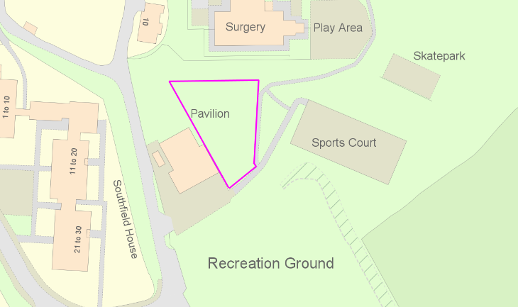
- The area between the medical centre and the Scout HQ, to the west of the path to the Gala Field is not one of the areas that AEG undertook to manage. It was left to grow on this summer with a grass path cut through by the Council. Unfortunately, this area is very full of docks. We were asked to advise on what to do about this and suggested that regular mowing by BMDC should be reinstated, while a longer-term plan for this area is considered. The concentration of docks in this area suggests the ground is very nutrient rich and so we think establishing a wildflower rich meadow is going to be difficult. An alternative, which would also benefit pollinators and improve this area, would be to establish a community orchard here. If this of interest to the Council, AEG would be pleased to take this forward and put together a proposal.

- We are continually being urged to plant more trees to help combat climate change. AEG is now holding a stock of saplings on its allotment at Lower Stamp Hill ready to be planted out in the village over the winter. Some of these will be used in creating the new hedge in Hoffman Wood Field as described above. Others could be planted elsewhere on Council-owned Green Spaces. AEG would also be pleased to suggest areas that might be planted should the Council so wish.

Jan Hindle/Rick Battarbee
AEG Steering Committee
06/11/2019

