Addingham Community Hub
Survey

Our new Community Hub has now been open to the public since June 2019.
After 3 months, we want your feedback! What do you think of the facilities? Are they what you want? How can we improve them? Have you any other ideas to help us with ongoing plans?
Please complete this survey to tell us what you think.
Thanks!
Facility in Hub: | Please add your comments/ideas here:
1.Cosy corner (for a chat and a coffee)  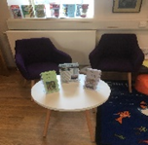 | Have you been in to try it out? What do you think?
2. Cosy children’s corner  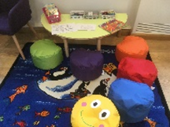 | What do you think of the activities – colouring, puzzles etc?
3.Newspapers and magazines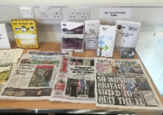 | We get 2 daily papers plus a couple of monthly periodicals. Would you like anything else?
4.Meeting space  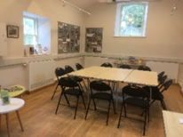 | Has your group used the meeting furniture? How did the room work for you?
5. Jigsaws 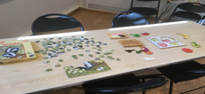 | What do you think of our jigsaw table? Have you added the odd piece? What sort of level of difficulty would you prefer?
6.Talks, presentations facilities  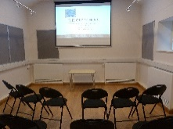 | Have you used the projection and sound system yet? How did you find the app?
7.Activities | Have you either organised or attended an activity session here? How did the room work for this?
8.Public computers with wifi 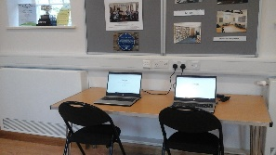 | Have you used the computers? If so, what did you use it for? Would you like any additional programs installed?
9.Exhibitions, displays  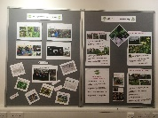 | Have you looked at the latest display? How do you think this works in the room?
10.Public information and guidance/advice leaflets | Are we providing the right sort of range of leaflets? What more would you like to see here?

Please note any other comments/thoughts/ideas for the Hub and the Library in the box below:

Please put your completed survey form into the box provided or pop it into the Hub later.

If you need any more information or want to make a booking, please drop in to the Hub and speak to Wendy – we’re open Monday to Thursday mornings and Friday afternoon – or email us on addinghampc2@gmail.com

