Addingham Environment Group Environment Weekend
May 18th and 19th 2019

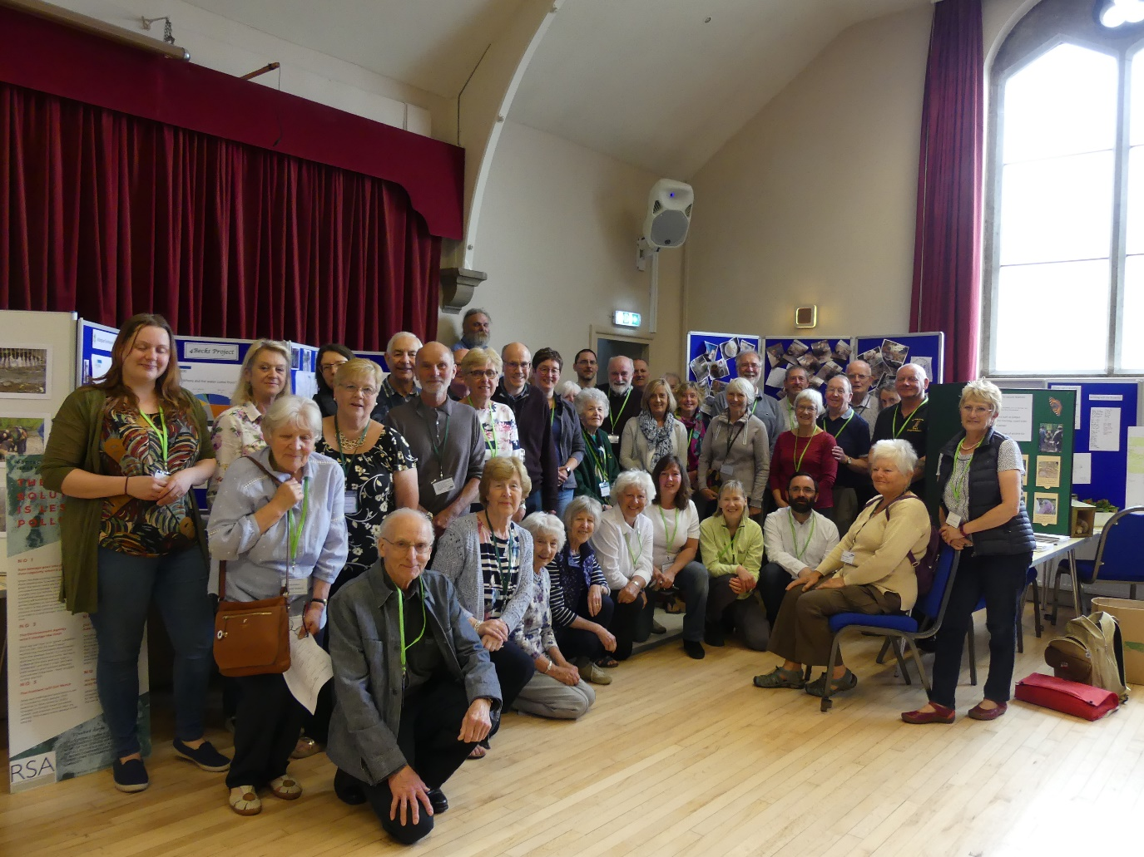
Approximately 300 people attended Addingham Environment Group’s annual Environment Weekend on May 18th and 19th. This year, to accommodate the growing interest in the Environment Group’s activities, the displays on the Saturday in the Memorial Hall were open to the public in the afternoon as well as the morning. There were over 30 displays covering the themes of local wildlife, water, zero carbon and waste and these were illustrated both by work of the Addingham Environment Group and by work of other invited local groups and organisations.

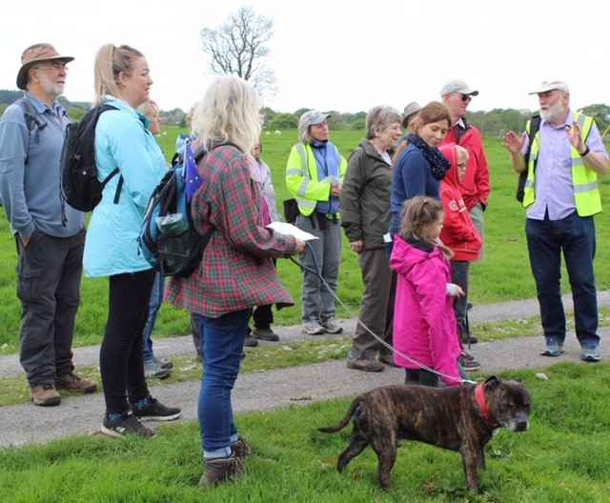
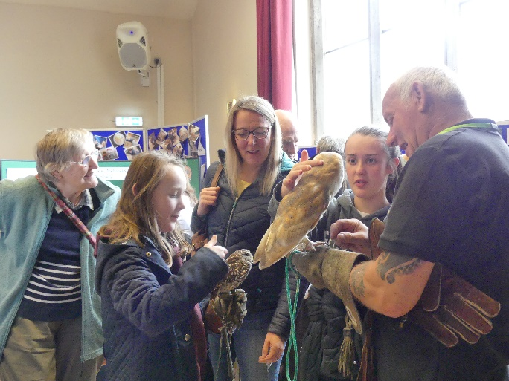
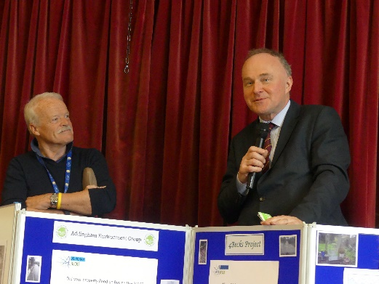
MP John Grogan paid a visit in the morning and said how impressed he was with the interesting work on display and pleased to see how much progress had been made by the Group since his previous visit in 2018. Addingham Civic Society Chair, Jim Robinson, thanked the principal organiser Gill Battarbee and her team for putting the event together so expertly. Over 60 volunteers were involved altogether, before during and after the event.

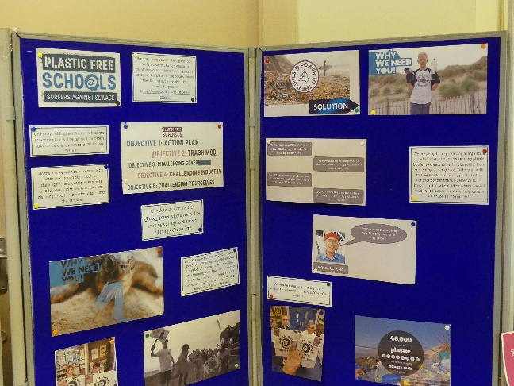
As in previous years young people were well represented. Addingham First Brownies displayed wildflowers that they had grown in pots from seed and Addingham Second Brownies displayed their work on wildflower planters and bug hotels. The Guides showed off their ideas for improving the Silsden Road Recreation Ground and Hoffman Wood Field as village green spaces. The Primary School presented two items, a display illustrating work carried out during their school science week and a poster demonstrating their recent work on plastic and waste based on their new status as a “Plastic Free School”.
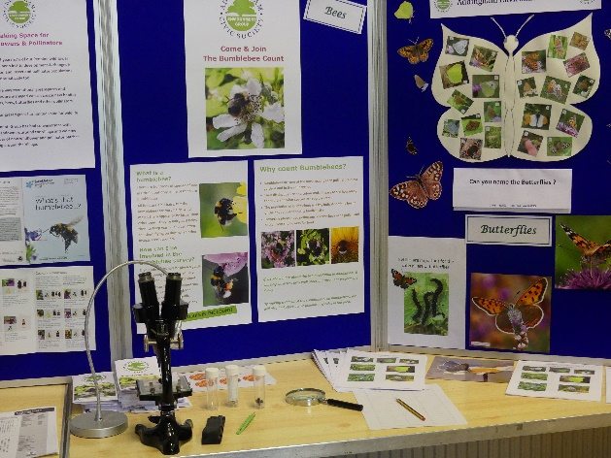
The Environment Group’s displays on biodiversity included material on local trees and hedgerows, on wildflowers, pollen and pollinators, especially bees and butterflies, and on bird populations. Local residents have been recording bird and butterfly sightings in the village for over two years now and these are forwarded to the Wharfedale Naturalists Society to be incorporated in their long-term archive. In addition this year the Environment Group, with the assistance of Catherine Mercer of the Yorkshire Dales Millennium Trust and Skipton-based entomologist Maurice White, is training residents to identify bumble bees. The overall aim is to increase populations of wildflowers in the village and help to reverse the decline in pollinators.
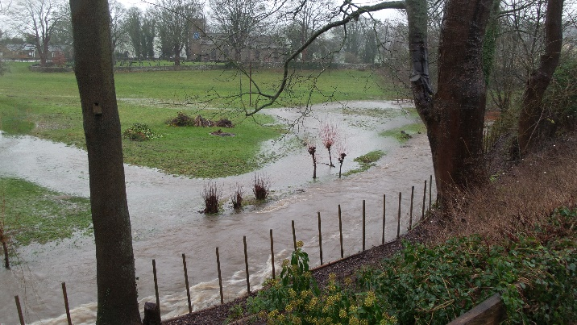
The Group’s work on the village becks focussed on the flood event of Boxing Day 2015 and the results of a village questionnaire designed to assess which parts of the village were most affected by the flood and what lessons could be learnt for the future. The survey was part of the 4Becks project, a project facilitated by the Yorkshire Dales Rivers Trust and funded by the Wharfe Flood Partnership. More results from the project will be presented at a drop-in session in the Memorial Hall on June 20th, starting a 6 pm.
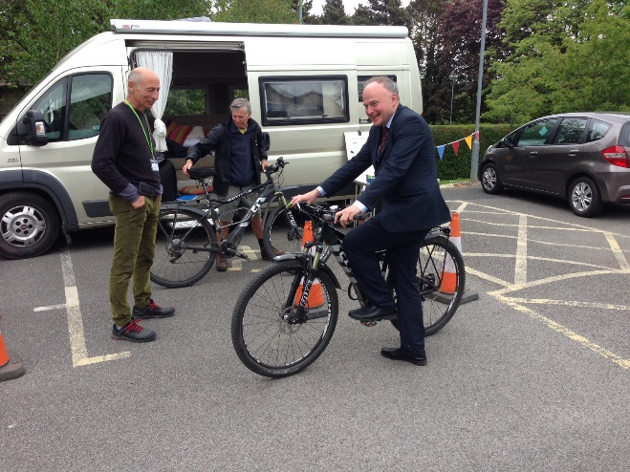
Under the Zero Carbon theme, village residents, using the WWF carbon footprint calculator (https://footprint.wwf.org.uk/), have been submitting their carbon footprint values to the Environment Group. Based on data from 40 people the village average is now 11.8 tonnes per person per year, with values ranging from 6.7 to 20 tonnes. The national target set for the UK by 2020 is 10.5 tonnes. The zero carbon displays in the Hall consequently were primarily concerned with the ways residents might reach that target over the next 12 months, including switching to LED light bulbs, fitting solar panels, switching to a green energy supplier, eating less beef and lamb and buying an electric car or bike.
To encourage people to think seriously about embracing electrically powered means of transport there was a demonstration of an electric car in the car park, courtesy of Mark and Jo Robinson, and a demonstration of electric bikes by Richard Solomons who invited visitors to take a trial ride.
The Group’s work on waste was represented by a display showing the success of the group in removing litter from the village becks and green spaces as well as its progress in reducing the use of plastic in the village and its attempts to encourage recycling. The display also invited volunteers to join the Zero Waste Group, and as a result of an excellent response a Zero Waste group meeting will be held soon to discuss what steps to take next.
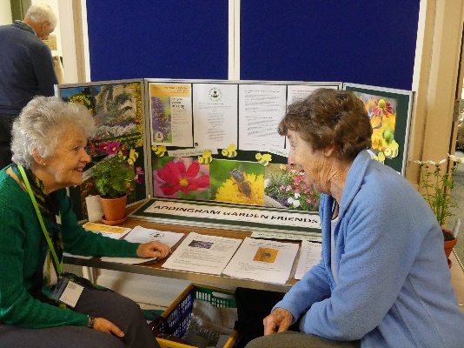
As in previous years there were many displays from other groups and organisations both from Addingham and further afield. Addingham Garden Friends showed how their planting policy is designed to favour pollinating insects and the Addingham Gardens and Allotment Society encouraged visitors to become allotmenteers and adopt environmentally friendly cultivation methods. There was also a display describing the history of the Church Orchard, created over 30 years ago using organic methods by long-term resident Derek Law. Sue Ross exhibited a series of paintings showing some of the environmentally-themed work of her Addingham Art Group and Pam Morgan designed a popular green activity table for children. Don Porritt’s topographic model of the village as always attracted much interest and Mary Jenner invited visitors to identify wildlife curiosities found in the village.
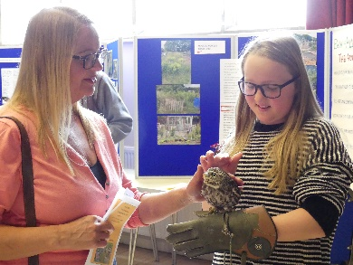
Steve Arabskys of the Yorkshire Owl Experience brought a number of rescued, mainly native owls that captivated both young and old visitors. Maggie Brown of the West Yorkshire Bats brought some rescued bats and used the occasion to improve her knowledge of Addingham bat populations by asking visitors to tell her where they had seen bats in the village. Yorkshire Wildlife Trust promoted the work they do throughout the county to manage and protect wildlife and Peter Miller encouraged visitors to find ways of thinking more about nature by taking part in YWT’s 30 Days Wild programme each day in June. Anne Cuthbertson from Wharfedale Tackles Plastic presented a poster pointing out the problems of plastic in the environment and the urgent need to reduce its use and improve recycling rates.
Karen Shackleton of the Ilkley Clean River Group outlined the problem of river pollution in Ilkley from raw sewage spills from the Ashlands Sewage Treatment Works and described the work of the River Group in tackling the problem. The Yorkshire Dales Rivers Trust brought their mobile classroom and SuDS house. In the classroom Catherine Mason encouraged visitors to play with moulding sand to experiment with surface water runoff in a river catchment and in the main Hall Charlotte Simons invited visitors to pour water on to the SuDS house to show how rainwater falling on roofs can be held back from running off swiftly into drains.
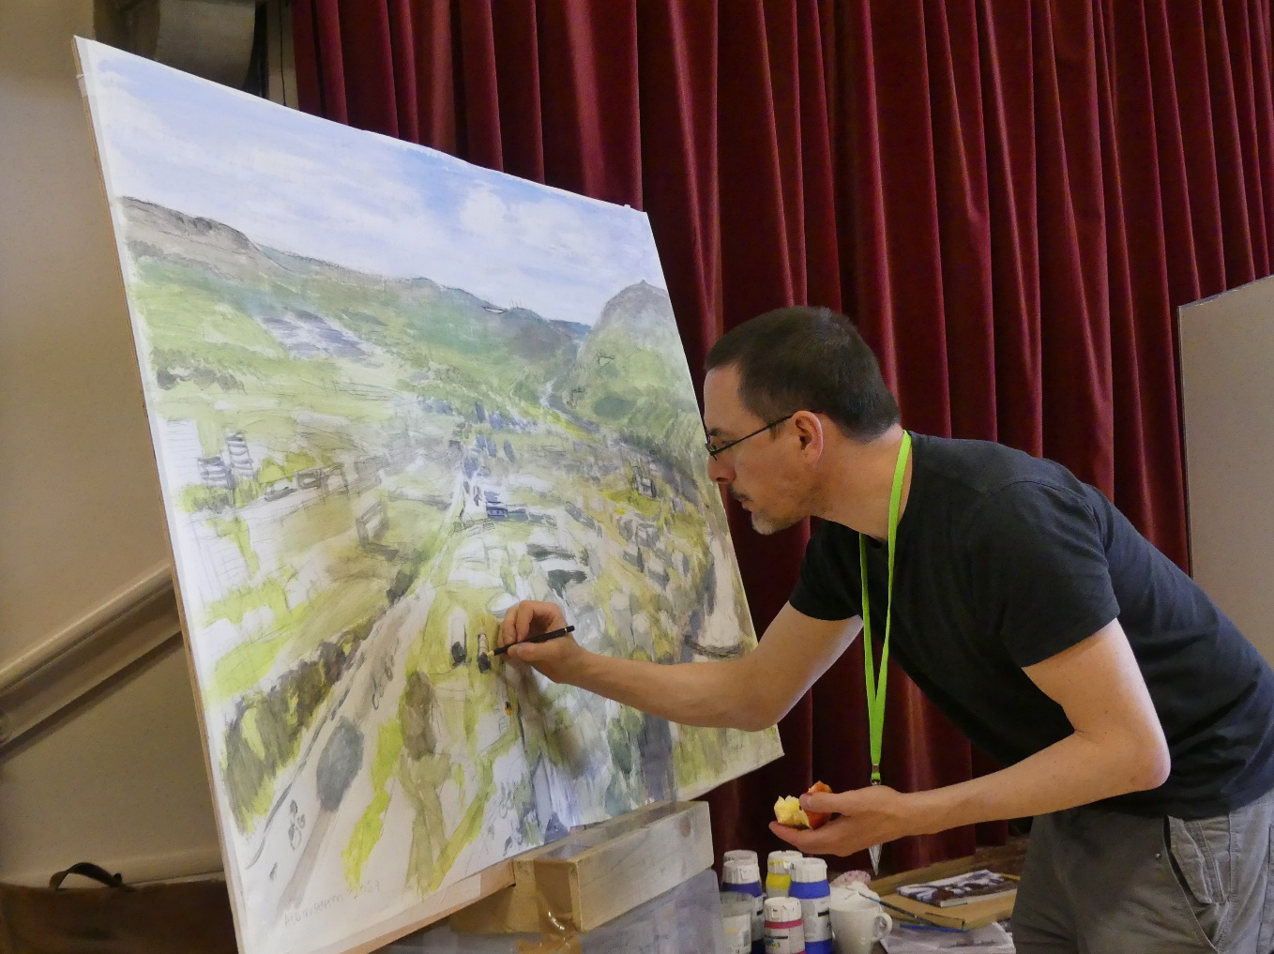
Andy Whitfield of Heritage Wild Flowers encouraged visitors to increase wildflower populations making seed available from his wildflower nursery in Bramhope. Andy Boyle from Otley Energy demonstrated how local communities within Wharfedale are getting together to explore how to create carbon neutral communities of the future, and artist James McKay from Leeds University painted an optimistic picture of Addingham as it might look in 2069 in a warmer world functioning sustainably and powered by renewable energy.

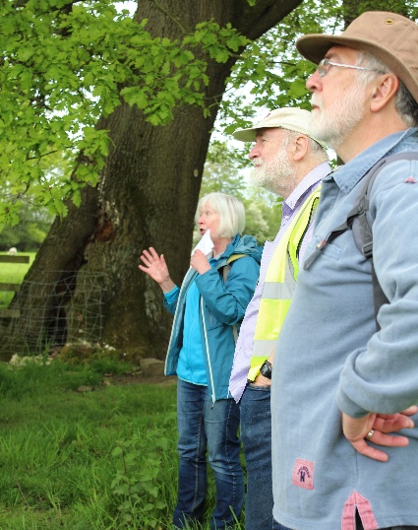
On the Sunday, the Environment Group organised a guided local walk from the village up to the lower part of Addingham Moorside, finishing at Lumb Ghyll Farm, courtesy of Judith Wallbank. The first stop was at Burnside on Main St where Rick Battarbee described the 4Becks project and its interest at Burnside in monitoring water levels, measuring water quality and protecting fish and bird populations. At the second stop, in the field behind the Sailor Public House, Jan Hindle described the formation of the Hollow Lane in medieval times, the medieval method of strip farming in the Southfield and pointed out the ancient and species-rich nature of the hedgerows.
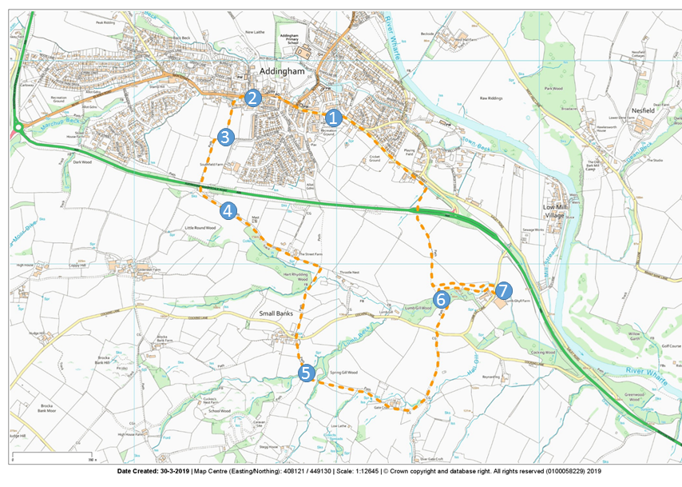
After crossing the bypass the walk followed a route connecting three of the village’s Local Wildlife Sites (LWS). Peter Miller pointed out that the first of these sites, The Street, runs along part of the route of the old Roman Road from Ilkley to Ribchester. Rick Battarbee explained that the site had been recently damaged but it was designated as a Local Wildlife Site by the West Yorkshire Ecology Service on account of its species-rich hedgerow and associated wildflowers. He took the opportunity at this stop to describe aspects of the local geology pointing out the sequence of sandstones and shales deposited in late Carboniferous times (320 – 315 million years ago) rising to the top of the Moorside and the role of meltwater at the end of the last Glacial period (about 15,000 years ago) in creating the distinctive valley to the south of the Street.
Having crossed Cocking Lane at Small Banks the next stop was at Stegholes, a Local Wildlife Site noted mainly for its diverse wildflower populations. Here village botanist Nicky Vernon described some of the plants in flower, including dog violet, wood sorrel, lousewort and bugle and some of the plants still in leaf due to flower in the summer, such as betony and common spotted orchid.
From Stegholes the walk headed east towards Gatecroft where the group paused for Maurice White to point out the importance of cuckoo flowers for orange tip butterflies in spring. At Lumb Ghyll Wood, the third Local Wildlife Site on the walk and Addingham’s only significant ancient woodland Rick Battarbee explained that its designation as a LWS was principally because of its bluebell populations which occur throughout the site. Prominent plants in flower on the woodland floor as well as bluebells were ramsons and greater stitchwort.
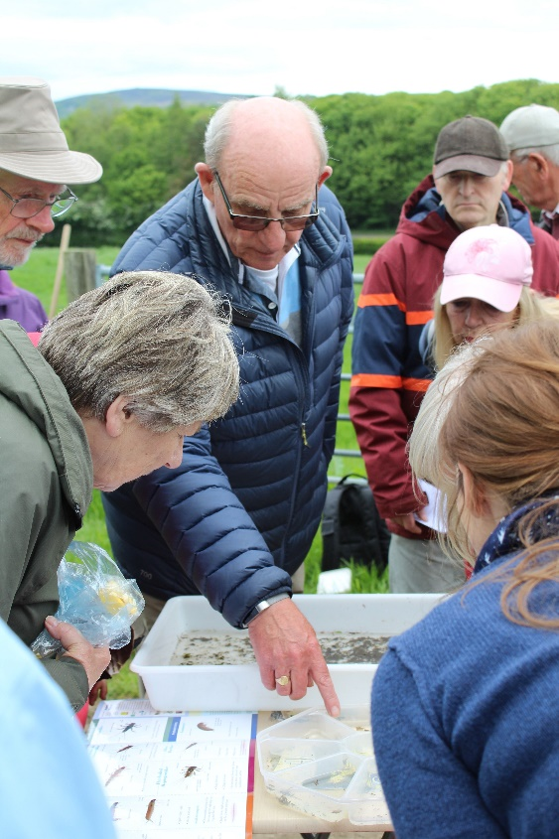
The final stop was at Lumb Beck where Steve Cheetham described the range of small invertebrates living in the beck. These included freshwater shrimps, leeches and the larval stages of several species of mayfly, caddis fly and stone fly. Rick Battarbee explained how invertebrates living in the becks can be used as indicators of water quality and suggested that the rarity of freshwater shrimps in Town Beck running through Addingham village, is probably due to its poor water quality compared to Lumb Beck.
The walk finished with refreshments provided by Jack and Beryl Robson and Jean Drysdale.
The Environment Group would like to thank all those who contributed to making the Weekend a success, preparing for the event and helping over the weekend in many different ways.
Special thanks to Debs Griffiths and Sue Hunter for taking the photographs shown here.

Rick Battarbee
29th May, 2019

