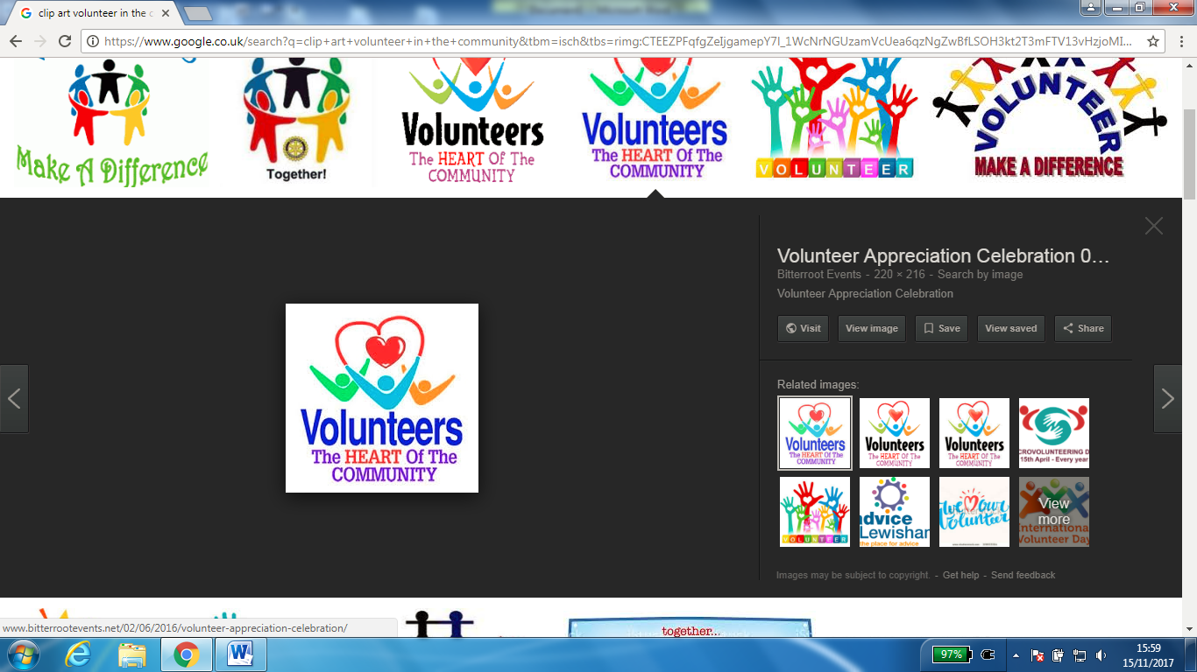

**VOLUNTEERING – ‘How To Get Involved’**

**Free event held at**

**Silsden Town Hall**

**on**

**Wednesday 28 February 2018**

**1pm- 3.30pm**

We would like to invite you to the above event. On the day there will be information stalls and presentations from Cllr Andrew Mallinson - CBMDC; Skipton Building Society and Speak with IT.

**Discussion Workshops:**

1. Group Development
2. How could you be involved in your community and make a difference?

Light refreshments will be available

To book your place; attend a workshop; or book a stall for this free event contact:

Liz Horn Ward Officer CBMDC on

01535 618008 or e -mail [liz.horn@bradford.gov.uk](mailto:liz.horn@bradford.gov.uk)

Department of Place