TOP TIPS

Password Protect everything!
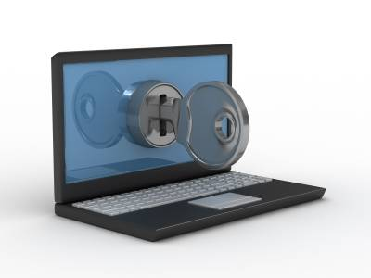
Setting a password on your devices is the first line of defense, just like locking the front door of your house.
Use a strong mix of characters and don’t use same passwords for multiple sites. For Example, SP1d3RM@n or your favorite line from a song. You can use ‘secure password check’ websites which advise you of how strong your password, for example Kaspersky.co.uk (not .com)
Ensure Wi-Fi passwords are in place and also that they are changed from the Original password.
Lock your devices
Never leave your devices unattended. If you need to leave your computer, phone, or tablet for any length of time—no matter how short—lock it!

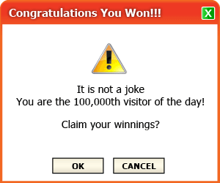
NEVER CLICK LINKS IN WEB-BASED POP-UPS

Always be careful when clicking on attachments, pop-up screens or links in email. If it is unexpected or suspicious for any reason, do not click on it.
If it seems too good to be true, chances are, it is!
You can block these type of pop-ups by simply going onto your internet and following these steps...
Click Tools, select options or internet options and click the Privacy Tab. Some users may have different displays such as content settings/Manage expectations/advanced settings. At the bottom of this tab you should see a ‘Pop-up blocker’ section, go on to this and select your preferred settings.

Keep security software current- Having the latest security software, web browser and operating system are the best defences against viruses, malware, and other online threats.
Computers, phones, gaming systems and other web-enabled devices all need protection from viruses and malware.
Browsing, such as banking or shopping, should only be done on a device that belongs to you, on a network that you trust. Whether it is a friend’s phone, a public computer, or free Wi-Fi, your data could be copied or stolen.

How do I check if a website is secure?
One way of checking is to look at the web address in your browser, make sure the web address starts with https://. The “s” means that when accessing that particular web site, all web traffic between your web browser and the web site uses the Secure Sockets Layer (SSL) – in other words it is encrypted. Now, if anyone manages to intercept the message, all they will see is gibberish.
You may also see a closed padlock in your web browser which also means it is secure.

Important to Remember:
- Do not log into a site if it is not secure as described above.
- Do not log onto a site if you feel it is a fake, call the company directly, remember if it sounds too good to be true, it probably is. It is always worth researching the site.
- Do not click on ‘remember me’ when shopping online or entering passwords.

KEEP IT LOCKED-KEEP IT PRIVATE
Ensure privacy settings are in place on social media sites such as Facebook, Snapchat, and Twitter Etc. It is extremely important that you have the correct Privacy settings on your social media profiles. If these are not in place you run the risk of anyone accessing your personal information, some of which can be used to commit crime or even steal your identity.
Also remember to save or screen grab any offensive messages
Keep the Computer in a Central Location. It’s much easier to keep tabs on any online activity when the computer is located in an open location rather than, if your child is using a computer in the privacy of their own room.

Be Aware of Your Internet Presence. Everything you do on the Internet is apparent to other users, and you should be aware of what they are seeing. In cases of cyber-stalking and identity theft, someone could use your name and information to create fake profiles or post public messages. Take a moment to "Google" yourself and see what others are seeing about you. This will keep you aware of any unauthorized use of your name, pictures, or personal information.
Make sure online games are age-appropriate. Some parents that would never let their children watch an over 18-rated film might think its ok to play with an over-18 game. But the violence is just as graphic and can have just as strong an effect on children. Parents should be familiar with PEGI – the rating system for games that you can buy in stores.
Talk to your child. If you’re concerned about your child’s internet-use/behavior then you should talk to them. If you think your child won’t talk to you, then ask a family friend, older cousin or sibling to have a chat. Communication is key, and you cannot keep your child safe unless you know what might be troubling them.
Set up parental controls. The four main internet service providers - Sky, BT, Talk Talk, and Virgin Media – have parental controls that you can switch on by visiting their website, logging in and managing your account/security settings.
You can also go onto www.opendns.com and set up controls/filters.

Some Helpful Sites
www.westyorkshire.police.uk
bdcyberproblemsolvers@westyorkshire.pnn.police.uk

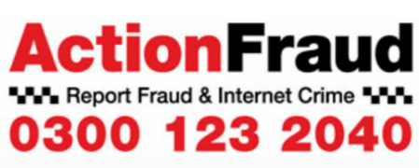
www.ceop.police.uk www.actionfraud.police.uk
www.thinkuknow.co.uk

Some helpful charities and advice sites
www.childrenssociety.org.uk www.nspcc.org.uk

www.childline.org.uk www.barnardos.org.uk

www.mesmac.co.uk/project/blast www.childnet.com

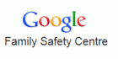
www.anti-bullyingalliance.org.uk www.google.co.uk/familysafety

www.bradford-scb.org.uk www.bradford.gov.uk

www.commonsensemedia.com www.internetmatters.org

www.getsafeonline.org www.iwf.org.uk

www.parentport.org.uk www.kidsmart.org.uk/parents

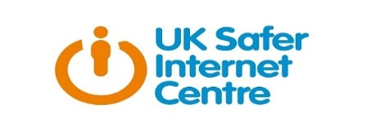
www.nidirect.gov.uk www.saferinternet.org.uk

www.net-aware.org.uk www.parentsprotect.co.uk

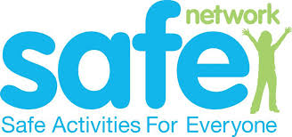
www.parentinfo.org www.safenetwork.org.uk

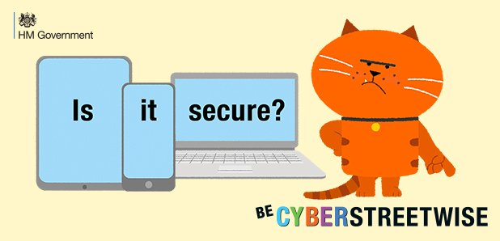
www.cyberstreetwise.com www.wisekids.org.uk

www.pitda.co.uk www.childline.org.uk/getinvolved/zipit-

Useful apps
Here are few examples of parental control apps that parents/guardians can use to monitor and manage their child’s phones, tablets etc.
Mobicip
Selfiecop
My mobilewatchdog
FamilyTime
Norton
Websafety
There are many apps that can be used to help protect and manage devices, these can be found searching on google.

Please Note: West Yorkshire Police do not endorse any product or company. The above are merely examples of the many apps that are available and can be used for Parental control.

