Shed door locks and hasps
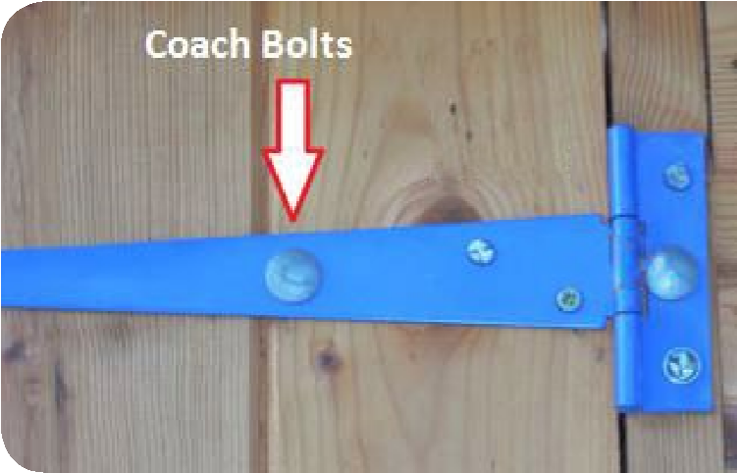
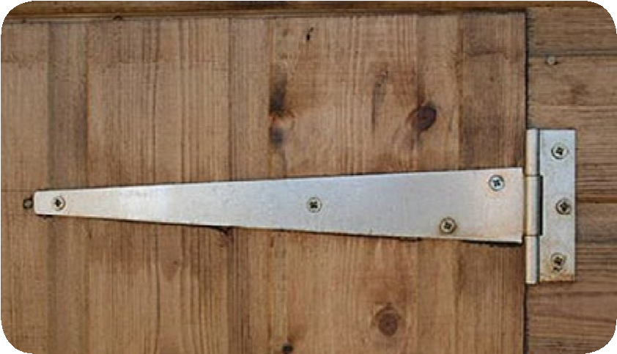
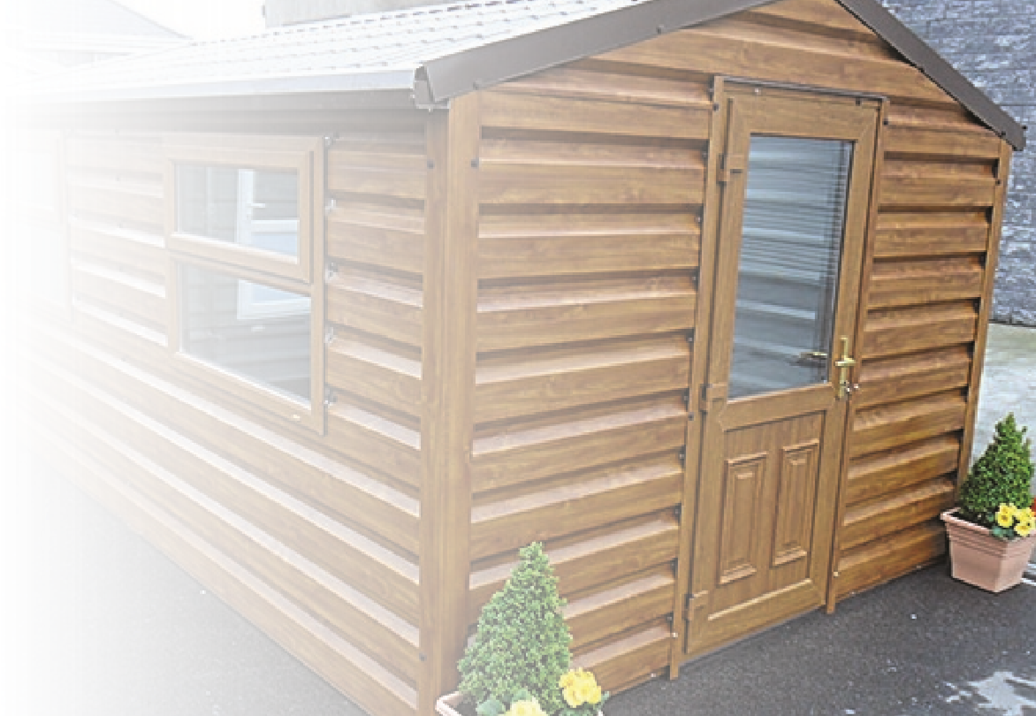
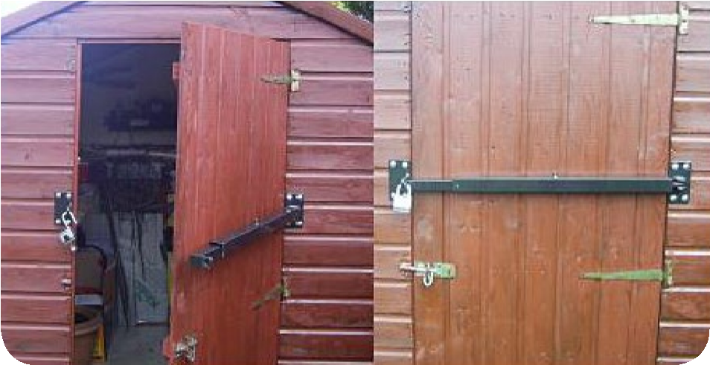
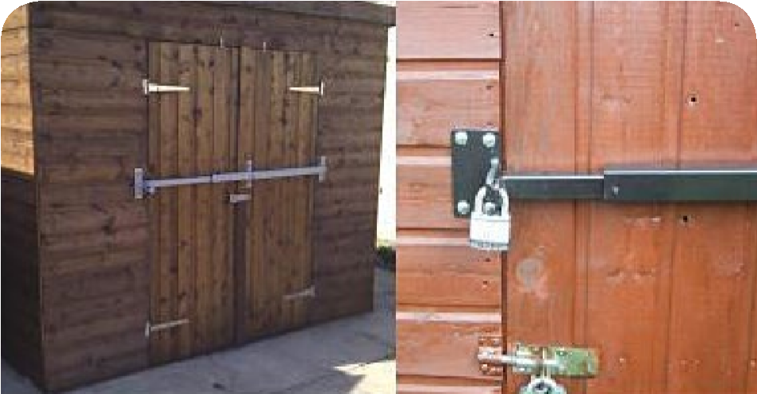
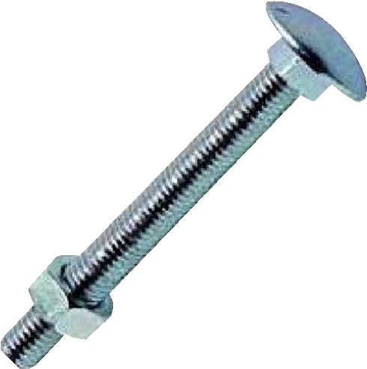
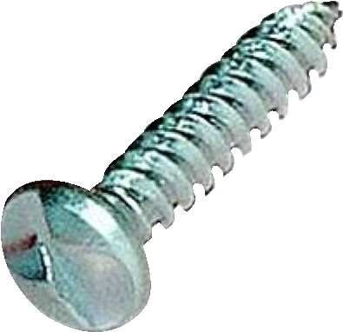
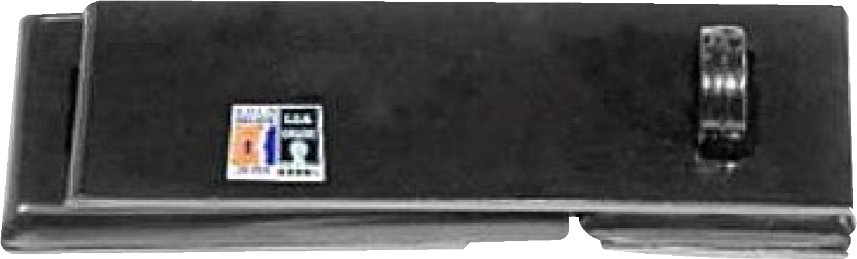
We recommend the use of Secured by Design products such as the hasp shown here, which protects the fixings
There are a number of security measures which are
fairly inexpensive and are quite easy to install.
The first things to look out for are the points of entry to
the shed; Doors - Are the hinges visible from the outside?
Are the screws accessible and easy to remove?
If they are, you may wish to consider installing “coach
bolts” and Clutch Screws (see below) to both the door side
and the frame side of the hinges. It is recommended that
the wooden door and the frame is reinforced with wood
or metal where the bolts are drilled through on the inside
of the shed.
Shed and garage
security advice
Offenders will target sheds which have
poor levels of security.
Coach
Bolt
Clutch
Screw
Clutch Screws
from being tampered with. A good quality
padlock tested to British Standard BN12320 with
a 3 – 4 rating for domestic use. Secured by Design
Once again the hasp can be reinforced on the inside
of the shed. Shed bars can be fitted to the front of
Shed bar
Shed bar
Shed bar
Shed bar
tested products are recommended by Police Forces the shed covering the door as a further security in the UK to offer a high level of security. measure.

Windows
Any window is a potential point of entry to the shed or garage. The glass can be obscured with various products to prevent offenders from being able to see the contents of the shed. Laminate sheeting can be applied to the glass on the inside giving it added strength and preventing it from breaking.
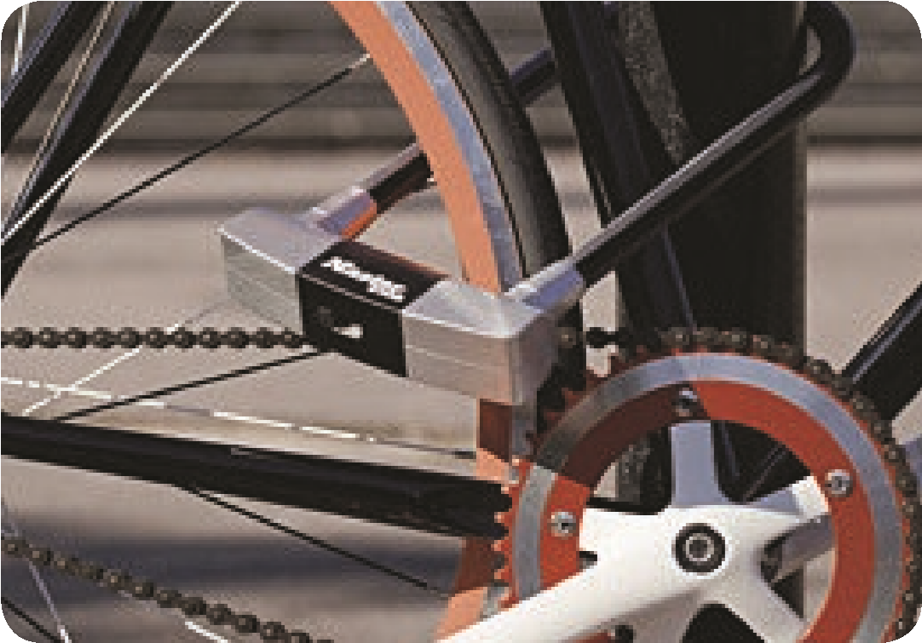 | Cycle Security  There are a number of Secured by Design products which can be installed inside sheds and garages to prevent the removal of bikes and other high value products such as lawnmowers etc. These products come in various shapes and sizes and are all securely fastened to either the shed frame or the base.  It is recommended that a good quality lock and chain is used to secure the bike etc. to the anchor.
Shed and Garage Alarms  There are a number of different alarm companies who supply alarms. These can vary in price from basic battery operated PIR type alarms to sensors which can | be linked to domestic alarm systems within the home. The advent of wireless technology has enabled this type of alarm to be used on sheds and garages.
Consideration should be given to the way that the glass is installed in the shed or garage. If the beading holding the glass is on the outside, it can be secured by using clutch screws or the use of silicon based adhesives.

Garage Doors
Devices such as the door defender shown here, once again recommended by Secured by Design,
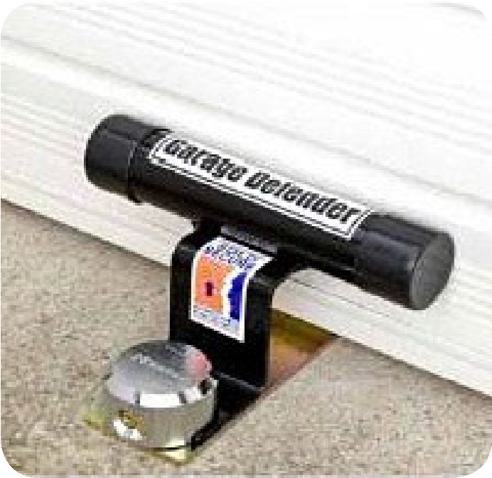
can be installed into a solid concrete base to prevent the garage door being raised. There are also other products of similar design available.

Shed and Garage Structure
Consideration should be made to the physical condition of the structure. If the wooden door is rotten on a shed for example, there would be little point in trying to secure the hinges. A replacement door of sufficient quality should be installed prior to any further security measures being added.
Your local Neighbourhood Policing Teams can be contacted in the first instance for further assistance or the Crime Reduction Officer will be more than happy to assist with any further security issues. Please call 101 should you require any more assistance.

