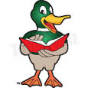
COFFEE MORNING
MEMORIAL HALL
To raise funds for
ADDINGHAM COMMUNITY LIBRARY

SATURDAY 6th May
10am to 11.30am
RAFFLE

Birthday cards on sale

£1 for COFFEE AND BISCUITS

