ADDINGHAM NEIGHBOURHOOD PLAN SITE ALLOCATIONS (SHLAA3 Methodology?)
- Following the workshop session on 3rd March 2017 this is a short note to set out the proposed process for the Addingham Neighbourhood Plan allocation of sites for housing. The key steps are identified along with key actions.

- The methodology set out below is broadly based on the CBMDC Issues and Options Site Assessment Methodology.

- Work up and agree site appraisal template and scoring based on the work already completed (Appendix 1).

- Scope sites for inclusion in study within the Village Boundary – all Green Belt sites are excluded (see note 11). Initial sites will include SHLAA3 2015 potential sites without planning permission (flesh colour shading on Figure 1); sites identified by Civic Society; and any other known sites within the Village Boundary.

- Ask CBMDC for comments on 3 and 4. Consult for two to three weeks.

- Revise 2 and 3 in light of response at 5.

- Publish final versions of 2 and 3.

- Run “call for sites” only seeking sites not in the Green Belt.

- Appraisal of sites identified at 4 and 8.

- Publish results of appraisal at same time as publishing Draft Plan for informal consultation.

- If you do wish to look at Green Belt sites my suggestion would be to assess these against a separate appraisal process to assess how they perform against the five purposes of Green Belt. The final site appraisal and scoring published at 7 could then be used to assess any sites considered to no longer perform a suitable Green Belt function. This work would have to identify separate parcels of Green Belt land adjoin the complete Village Boundary (see http://www.pendle.gov.uk/downloads/download/2985/green_belt_assessment for an example from Pendle).
Figure 1. SHLAA3 2015

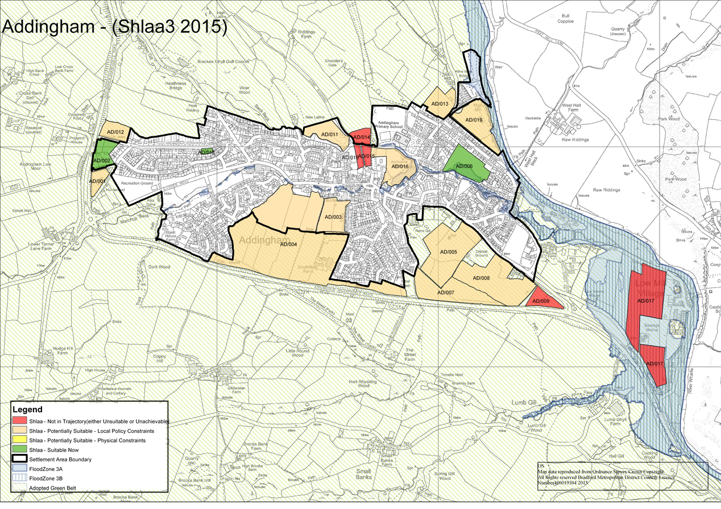
Appendix 1
SITE REFERENCE/LOCATION

BASIC SITE INFORMATION

Site Name
BMDC SHLAA Ref
Site Address
Site Area (hectares)
Flood Zone (rivers & seas)
Flood Zone (surface water)
Site capacity (no. units)
Existing Use
Brownfield/Greenfield %
RUDP Village Green Space
Site located in Conservation Area
Site located in Green Belt
Site Description

(A) INITIAL SCREENING OUT OF SITES (ref BMDC Stage 3)

AVAILABILITY:  The land is available for development (i.e. the landowner/developer is willing to sell/develop the land).  (NB If in the BMDC SHLAA then it is assumed available unless it is known otherwise) | Yes/No/Unknown
SITE WHOLLY IN FLOOD ZONE 3b | Yes/No/Unknown

(B) GROUPING & PRIORITISING REMAINING SITES (ref BMDC Stage 4)

Core Strategic Policy SC5

Priority 1: Re-use of deliverable & developable previously developed land & buildings within settlements

Priority 2: Mixed green field/brownfield sites within settlements

Priority 3: Greenfield sites within settlements

Priority 4: Local green belt releases to the built up areas of settlements

(C) BRADFORD COUNCIL SITE ASSESSMENT METHODOLOGY – TECHNICAL APPRAISAL OF SITES – SUITABILITY [ref BMDC Stage 5]

 | RED | AMBER 1 | AMBER 2 | GREEN | NOTES
HIGHWAYS/ACCESS

DRAINAGE/FLOOD RISK
HERITAGE IMPACT

WILDLIFE/ECOLOGICAL
IMPACT

TREES/WOODLANDS

LANDSCAPE IMPACT

OPEN SPACE/GREEN
INFRASTRUCTURE

(C) NATIONAL AND LOCAL POLICIES/PRIORITIES - NPPF AND BRADFORD CORE STRATEGY

POLICY/PRIORITY |  | NOTES
Encourage/prioritise use of Previously Developed Land
NPPF/ BMDC Policy SC5 (use this policy to sift sites)

Protect Green Belt (unless “exceptional circumstances”)
NPPF/BMDC Policy SC7

Prioritise use of land with least environmental/amenity value
?
Protect the South Pennine Moors SPA & SCA & their zone of influence (Zone B)
BMDC Policy SC8

(D) ACHIEVABILITY

- Physical Constraints
- Current Policy Constraints (eg would require Greenbelt Release/ Village Green Space designation)
- Development Viability
- Timeframe for development

CONCLUSION

DEVELOPMENT ACCEPTABLE ? N0. OF DWELLINGS
YES □ NO □

Sites AD/002 part only, AD/003, AD/004 part only, AD/011 and AD/016

