ADDINGHAM HUB
An exciting new public space in the heart of the village!

The Parish Council, working with the Community Library, Civic Society and other village volunteers has plans to re-open the Old School as a new community building.
Come along on 8 July to find out more.

Sunday 8 July
2pm
Memorial Hall (Presentation: 2.30pm)
Plus: refreshments and raffle!

Our Community Library looks like this:
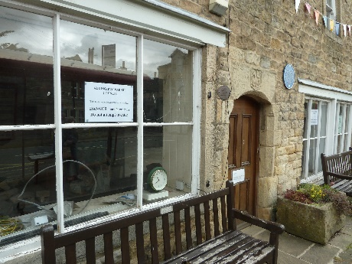
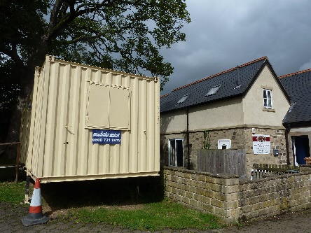

because the Old School looks like this:

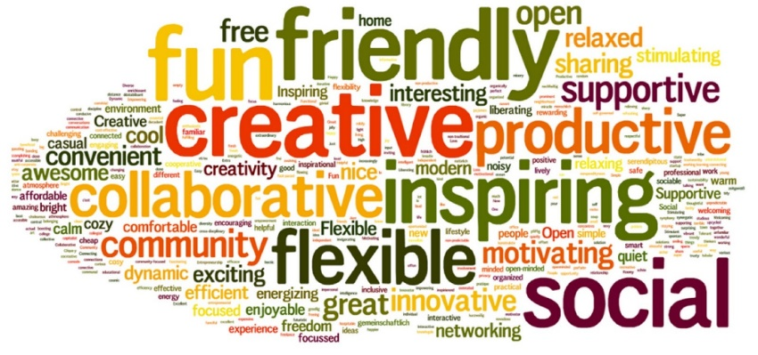
With your support, we can make something new, like this:

The Addingham HUB!
How to contact us:
clerk@addingham-pc.gov.uk

What is a Community Hub?
Community hubs offer multi-purpose, community-led services, providing or hosting a range of different activities, and bringing local people together to form new relationships and support networks.
Hubs are being set up across the country, and are valued within their local communities:
• They offer a local base for people to access services and information, so the services are more accessible and useful
• They often provide an opportunity for socialising, helping people to solve problems before they escalate into bigger problems, and helping improve social cohesion in a community
• They can offer a safe place where people can come in for a coffee or training course, and access information on additional services and advice
• Community hubs can provide a more holistic approach to develop informal networks. They often have an ‘open door’ policy and are able to help people access a range of services under one roof.
In Addingham, there are no public buildings currently open for informal drop-in social occasions during the day, and none that offer a free public space for small group meetings and activities. We have the opportunity to create this in the Old School, once it has been repaired and the Library can move back in again.
We are proposing to incorporate both the existing traditional library services, plus a new village heritage facility, offering (themed) heritage displays, exhibitions, talks, and research facilities for the digitised archive material, into an integrated community hub which can be used flexibly to accommodate a range of community uses, such as:
- Leaflets/posters providing information on local services
- Small group training opportunities (eg crafting, IT skills, music appreciation)
- Coffee mornings
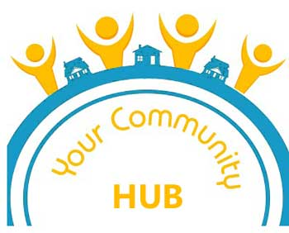
- Environment Group events/meetings
- Children’s reading groups
- Children’s small group activities
- Homework club
- Adult reading groups/book clubs
- Adult music groups/clubs
- Jigsaw activities
- Informal newspaper corner
- Village and tourist information
- Local walks information and displays
- Digitised village diary display

A Community Hub in the Old School?
So, how would these ideas work in the Old School?
The Parish Council has had plans drawn up to create the right sort of space on the upper floor of the Old School, which will be linked to the Library on the lower floor with a new internal staircase. The building will be newly accessible to everyone, with improved disabled access and an indoor toilet.
The organisation of activities and use of this space is up to us! What do we want it to look like inside? How do we want to run and manage it? How do we see it developing in future?
Interested? Come to our publicity event on 8 July at 2pm in the Memorial Hall to find out more.
Could you help? If so, fill in the form overleaf.

[Insert plan revised: May 2018]

Addingham Hub – what do you think?

Do you support our proposals? Yes / No
If so, please give your comments here:

If you have any ideas for other services which the Hub could provide, please list them here:

Would you like to be involved in this project? Yes / No
Would you be interested in working as a volunteer in the Hub? Yes / No
If you would like to be involved in either capacity, please provide your name and contact details below. For data protection reasons, please also tick the box to give your consent for us to use these details to contact you in connection with this project.

Name ……………………………………………………………………………
Email …………………………………………………………………………….

I give consent for my personal contact details to be used in connection with the Addingham Hub project. Please tick here

Return to: The Old School LS29 0NS

