**Street Surgery**

**Addingham**

**ON**

**Tuesday 15 May 2018**

**IN**

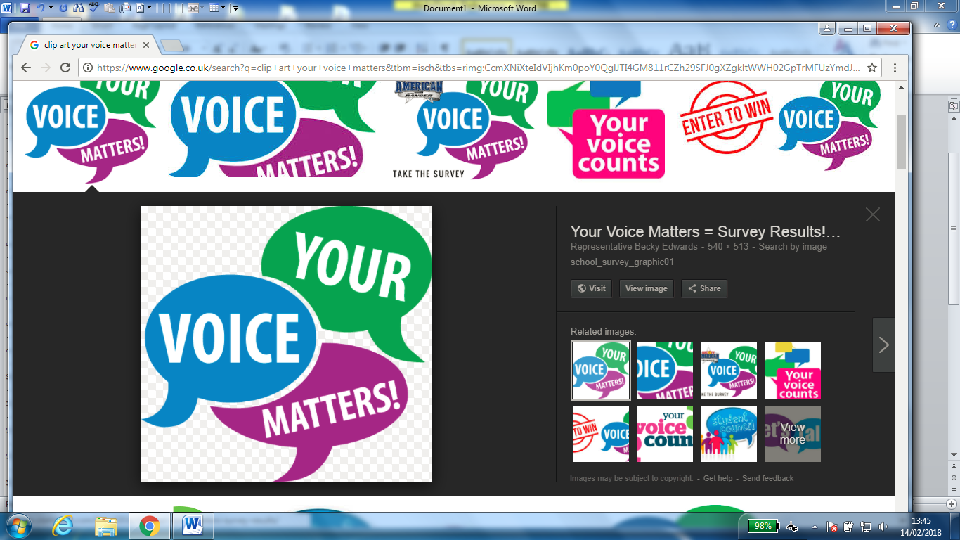**Partnership with West Yorkshire Police; Addingham Primary School; Keighley Co-ordinators Office CBMDC; Warden Service CBMDC; Ward and Parish Councillors.**

**AT**

**3.15pm – 3.45pm: Officers and Representatives to meet and talk with Parents at Addingham Primary School about local issues.**

**3.45pm – 5pm: Area Walk - A - Bout setting off from Addingham Primary School.**

**5pm – 7pm: Drop - In at Memorial Hall Addingham Main Street to talk to representatives about your local and area issues.**

**THANK YOU**

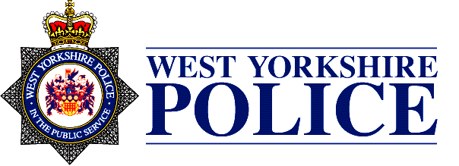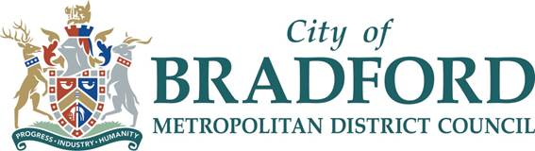**FOR SUPPORTING THE STREET SURGERY PROGRAMME IN Addingham - Craven Ward**