ADDINGHAM NEIGHBOURHOOD PLAN FORUM

Addingham Parish Council is the qualifying body for preparing a Neighbourhood Plan setting out how residents would like to see the village develop and improve over the next 15 years. The Plan could include matters such as protecting the green belt and open greenspace, supporting and encouraging local businesses, where new housing should be located, what new facilities are required, green/sustainability issues, and other topics.

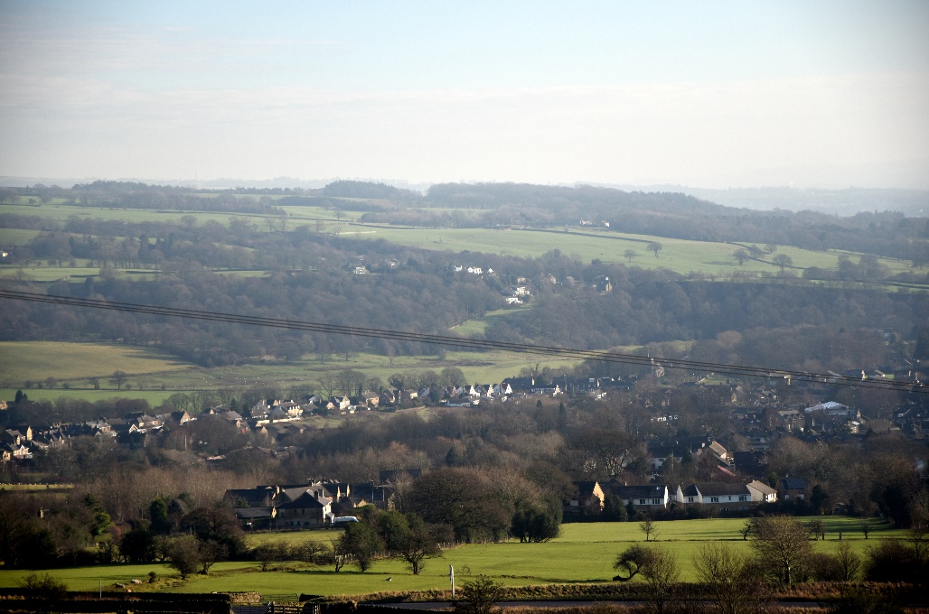

The Neighbourhood Plan must take account of residents’ views. The Plan is being led by the Parish Council, who have established a Neighbourhood Plan Forum to consult with village residents and businesses in order to identify ideas and proposals for inclusion in the Plan. Current membership of the Forum is listed on the back page of this leaflet.

An Information and Consultation Meeting has been arranged where you can learn more about the Neighbourhood Plan process, speak to members of the Forum, and give your views and ideas on the future of the village.

NEIGHBOURHOOD PLAN MEETING
******
MEMORIAL HALL
******
THURSDAY 3 NOVEMBER

DROP IN ANY TIME BETWEEN
3.00 pm - 7.30 pm

There will be brief presentations giving more information on the Neighbourhood Plan process at 4.30pm and 6.30pm

