Low Mill Lane Viewing Spot.

We have had an approach from a couple of our members regarding the ‘site’ at the end of Low Mill Lane, just before you enter the Village. (you will all know where it is but here’s a photo anyway !)
The thought being that this little area could possibly be enhanced and turned into a nice attractive spot for people to ‘linger’ and take in the views..... ! It is in a bit of a mess, it is used from time to time for depositing garden waste, it is difficult under foot and the railings are virtually non existent.

It would need clearing, perhaps the wall area made secure to prevent would be visitors falling into the river (!) and ideally a stone bench or similar located overlooking the river. We would not look to add anything to the site that would hamper or detract from people accessing the site or getting close to the wall. Any work would have to be sympathetic to the location and the surrounding area and at the same time retain its ‘rustic feel’ !
It’s very early days but it’s something the Society is currently supporting. Rick Battarbee also thinks this could be a very worthwhile project, from a ‘green’ angle.
I gather Jane is going to report the missing and damaged railings to Bradford Council.

I am looking for Council support for this project and if it proceeds then help to get the necessary permissions in place. Financially, this is a project that the Society would fund, outright. In the meantime we will continue to canvass support and comments/suggestions.

Finally, you may recall that some years ago the Society installed a wooden bench just opposite this spot, which was stolen within a week. We’ll not fall into that trap again !

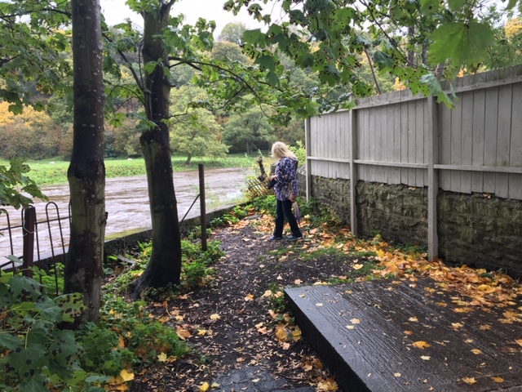
Jim Robinson

