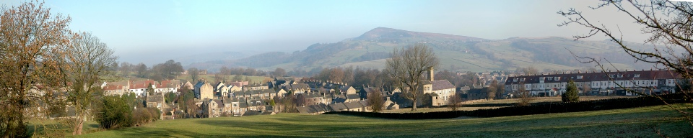
Addingham Environment Group
2018 Achievements and 2019 work programme
Last year, 2018, was our second full year. It saw our membership grow from 50 to over 150 and it saw the launch of several new projects, not least the “4Becks” and “Zero carbon Addingham” projects. We were also able to carry out a full programme of field work involving over 50 volunteers turning out on Saturday mornings variously to litter pick, rake grass, sow wildflower seed, bash balsam, clear culverts and plant hedges.
Here now is a summary of our achievements in 2018 and our plans for 2019 ordered according to our main themes of Biodiversity, Climate Change, and Pollution and Waste.
Much of our 2019 programme will be a continuation of our 2018 programme, but new in 2019 will be:
- A bumble-bee project co-ordinated by Maurice White (Skipton) involving volunteers, training in identification and surveys of our village bumble bee populations;
- A “Zero Waste” project which will be an expansion of our “war on plastic” project to include all waste and to encourage recycling;
- A stronger focus on village trees within our “trees and hedgerows” project;
- Closer collaboration with the Primary School learning about wildlife, energy, and water, both in theory and practice; and
- The formation of Addingham Saplings, a new children’s group, coordinated by Debs Griffiths, to help children and their families enjoy and learn more about village wildlife.
Biodiversity recording
Checks with the West Yorkshire Ecology Service (WYES) show that wildlife in Addingham is under-recorded. The first priority in protecting and enhancing biodiversity in the village is to know which species occur here and whether their numbers are increasing or decreasing. We set the Biodiversity group up in 2017 to co-ordinate our recording efforts and provide the necessary taxonomic support for our other projects, especially on wildflowers, trees and hedges, pollinators and aquatic life.
2018 Achievements
- Jan Hindle has coordinated, chaired and minuted three meetings of the group over the year;
- We have built a team of 20 bird recorders reporting to Chris Acomb;
- Chris has collated 863 reports and produced an annual report showing list of 71 species sighted in 2018 (69 in 2017);
- Diane Morris has trained a number of helpers in butterfly identification and produced a report on species seen in the village. The best site is the Old First School site. Records have been submitted to the Wharfedale Naturalists Society;
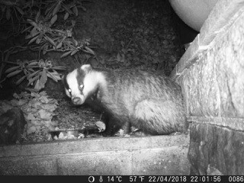
- Rick Battarbee has begun recording sightings of mammals, amphibians and fish based on records sent in. Highlights include otters, badgers and hedgehogs caught on night-time camera traps. Most data are for hedgehogs. The otter records have been sent to WYES;
- Peter Miller is recording fungi;
- Nicky Vernon and Heather Burrow have surveyed our wildflower patches (see below) and hedgerows (see below);
- Mark Penny has mapped the distribution of trees with TPOs in the village using QGIS and created a spreadsheet giving species names, location and date designated;
- Daniel Ross has managed wildflower planting at the Old Station Way site and provided guidance on other sites.
2019 Plans
- Continue meetings;
- Continue all recording schemes;
- Develop a bee recording scheme and train volunteers in bumble bee identification, advised by Maurice White of Skipton;
- Submit data to WNS and WYES;
- Continue to focus on the biodiversity of all sites threatened by housing, especially the Old First School site;
- Develop a biodiversity programme with the Primary School based on habitats within the school grounds.
Green spaces
Our village green spaces are hugely valued for walking, recreation and wildlife. Many ideas for improving them emerged during the consultation process carried out in 2017 for the Neighbourhood Plan. Our plan in 2018 was to work with the Parish Council and the wider community to take some of the ideas forward.
2018 Achievements
- Jan Hindle continued working with the community to assess the value of village green spaces for amenity, recreation and wildlife;
- Jan has been responsible for developing policy and writing the Green Spaces section of the Neighbourhood Plan;
- Jan has been a member of the Neighbourhood Plan Forum and is a member of the new NP Review Group;
- A green space design exercise was conducted on the Environment Day, and a project with the Guides to generate ideas for enhancement to Hoffman Wood Field and Silsden Recreation Ground was devised.
2019 Plan
- Jan to continue representing the Group views on environmental matters on the NP Review Group;
- Continue to work with the Parish Council to create a plan for Hoffman Wood Field. Seek the Council’s approval for improving the management of the field margins for wildlife (phase 1) and design an outline plan for enhancements for play and recreation (phase 2) for consultation with the community;
- Seek the Parish Council’s approval to develop a plan for Silsden Road Recreation Ground, which addresses both improving its play and recreational value, and introducing sustainable urban drainage measures as part of the 4Becks Project.
Green Belt
Bradford Council will be carrying out a review of the Green Belt in the District and together with the Civic Society’s Planning Group, we will be keeping a close eye on this and continue to compile evidence of the value of the Green Belt around the village.
2018 Achievements
- No progress – review not yet started
2019 Plans
- Watching brief (Green Belt Review programmed for early 2019);
- Prepare to respond to consultation opportunities and contest environmentally damaging proposals;
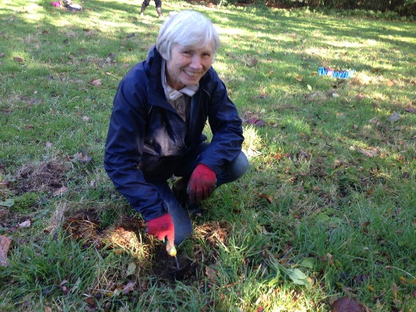
Wildflowers and pollinators
We now manage (with the help of Garden Friends) some of our village green spaces (these include Old Station Way, several plots in the Memorial Recreation Field, and the Skipton Road bank near the bypass) where we aim to encourage wildflowers and attract bees and butterflies. We will be looking for help to sow seeds and rake off cut grass once spring arrives, as well as enlist volunteers to grow wildflowers in pots to be planted out later as plug plants.

2018 Achievements
- Successfully altered Bradford Council grass cutting regimes to leave wildflower patches uncut through the spring and summer;
- Recruited ca 20 volunteers to grow wildflowers in pots from seed for later planting out as plug plants;
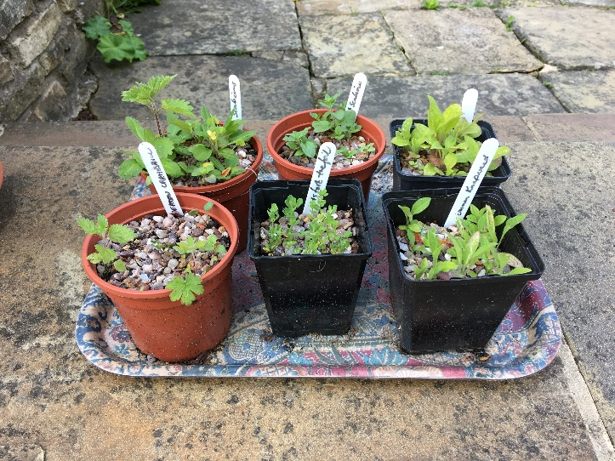
- Used volunteers to rake off grass cuttings at key sites, especially Skipton Road bank;
- Observed success of yellow rattle planting in 2017, especially on the Skipton Road bank;
- Collected yellow rattle seed from plants on Skipton Road bank and used to sow yellow rattle elsewhere on the bank;
- Acquired additional yellow rattle seed from Andy Whitfield (Burley) and used to sow in the Memorial Hall Field;
- Used volunteer working parties to remove broad-leaved dock from the MUGA bank;
- Planted out oxe-eye daisy, red campion, and field scabious seedlings donated by Nicky Vernon, Alison Leatherhead and Richard Solomons in the Memorial Hall Field triangle and Skipton Road Bank;
- Planted out plug plants grown from seed (above) including betony and birds-foot trefoil in the Memorial Hall Field triangle;
- Sowed a wildflower/grass mixture from Andy Whitfield on the bare soil areas of the MUGA left from broad-leaf dock removal;
- Given permission by St Peter’s Church to create a wildflower meadow along a strip of land in Church Field 10 m wide along the northern part of the western boundary thanks to Anne Hodgson’s supplication;
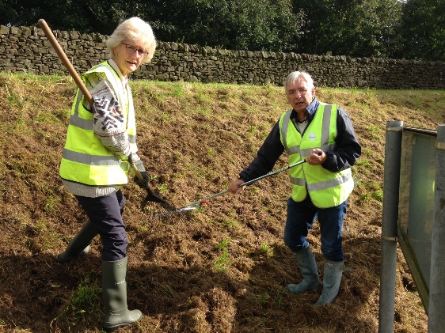
- Received promises from the Methodist Church to promote wildflower populations in the Church graveyard starting spring 2019. Judith Ellis from the Church has offered to lead;
- Discussions are ongoing with Paul and Barbara Henderson about the creation of a wildflower area in the grounds of Farfield Quaker Meeting House;
- Agreed to create a wildflower margin around the small field at the back of the Scout Pavilion (see below);
- Nicky Vernon and Heather Burrow surveyed the botany of the key sites three times in the year during Spring and Summer to provide a baseline data-set.
2019 Plans
- Continue at all sites, maintaining appropriate grass cutting regimes with Bradford Council;
- Carry out botanical surveys in spring and summer, including the Old Station Way site to assess degree of change from 2018to 2019;
- Continue with wildflower seed growing in pots, recruit new volunteers;
- Erect signage in the Memorial Hall Field and in Church Field to explain operations to passers by;
- Remove new-growth docks from the MUGA bank early in the season;
- Continue working with Bradford Council by raking off grass cuttings in September;
- Introduce wildflower plug plants and seedlings to the Church Field strip;
- Begin work on Hoffman Wood Field margins, and the Methodist Church graveyard ;
- Take part in the Yorkshire Dales Millennium Trust (YDMT) Bee Together project that is due to begin in early 2019;
- Survey all sites for butterflies and bees according to protocols to assess response to wildflower planting.
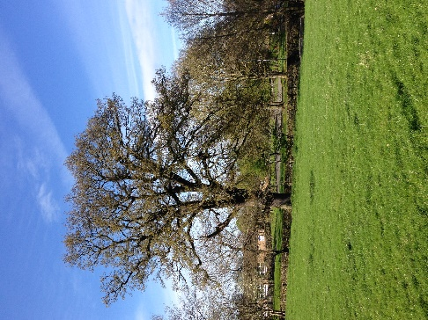
Trees and hedgerows
Trees provide habitat for insects and birds, store carbon, control flooding and create cooling shade for freshwaters. The trees we have need to be protected (especially those with Tree Preservation Orders), more trees need to be planted, ancient hedgerows need restoration and we need to create new hedgerows where possible. In 2018 we hoped to put more emphasis on trees and hedgerows. Ideas included collecting and germinating seed from our own local trees such as acorns from the famous Richard Smith tree in the Garth or alder from along the beck sides, and sourcing trees from the Woodland Trust to plant hedge and small woodlands.
2018 Achievements
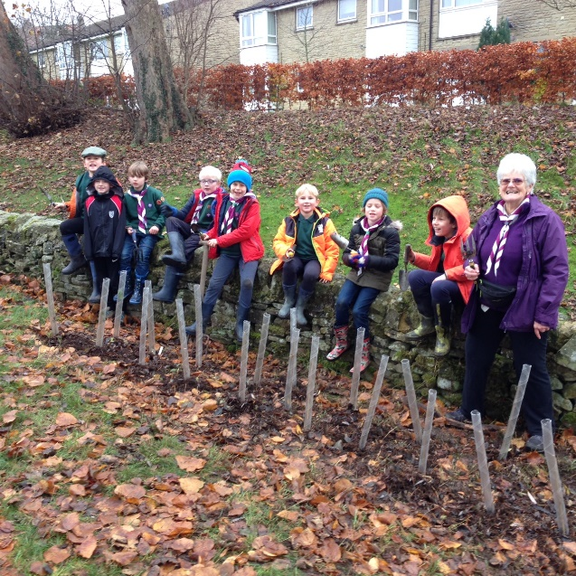
- Detailed survey of Hollow Lane hedgerow by Nicky Vernon, Heather Burrow and Jan Hindle;
- Survey of Long Ridding hedgerow by Nicky and Heather;
- Data sent to WYES with request that these hedgerows are considered for designation as Local Wildlife Sites;
- Worked with the Cubs to plant hedge trees at the bottom of the Memorial Hall Field and at the back of the Scout Hut with plants supplied by the Woodland Trust;
- Assumed management of Townhead copse, created log pile and planted native bluebell bulbs;
- Mapping of all TPOs in the village by Mark Penny and creation of Excel spreadsheet of Tree attributes as recorded by Bradford.

2019 Plans
- Continue attempts to have old hedges recognised for their botanical and archaeological values;
- Continue working with Cubs to extend the hedge at the back of the Scout Pavilion with plants from the Woodland Trust;
- Use new TPO maps to survey all designated trees, check their continued presence, accuracy of ID and add more attributes (e.g. on height and girth) to the TPO spreadsheet;
- Initiate further tree and hedge planting in Hoffman Wood Field margins.
Village hedgehogs
Hedgehog populations have declined massively in the UK and hedgehogs are now quite rare in the village. How many remain? Where do they live? What can be done to help them? This is a project led by the First Addingham Brownies co-ordinated by Gill Moon, but needs to involve everyone.
2018 Achievements
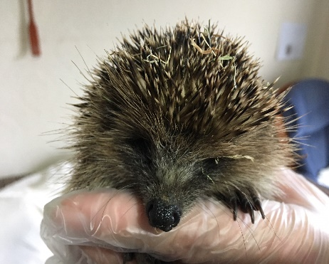
- Conducted a number of hedgehog-themed sessions with First Brownies;
- Helped First Brownies make a map of hedgehog distribution in the village;
- Produced a leaflet with help of the Brownies on hedgehogs for distribution to neighbours;
- Publicised the project using email and Facebook;
- Recorded nocturnal activity of hedgehogs using camera traps in response to requests from residents;
- Recorded 49 sightings sent in by residents (but how many individuals does that represent?)
2019 Plans
- Continue recording sightings and mapping distributions;
- Raise greater awareness of hedgehog presence by leafleting/speaking to neighbours of households where hedgehogs have been sighted;
- Assess potential for habitat improvement especially connectivity of village boundary and adjacent countryside.
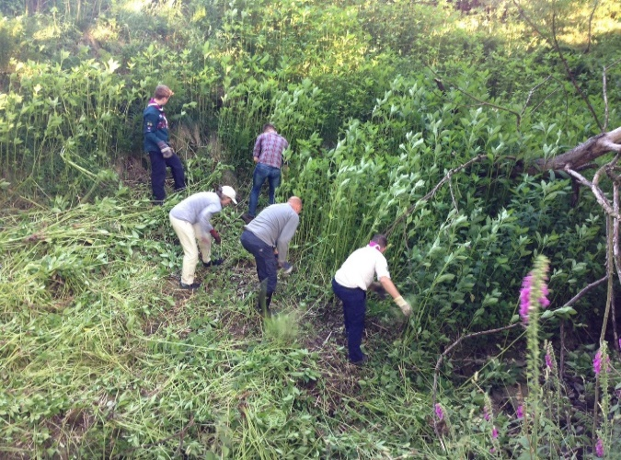
Eliminate Himalayan balsam from the parish
Himalayan balsam is spreading rapidly throughout the UK, mainly along river and stream networks. It is a non-native invasive species and it is subject to a national programme of eradication. We started in 2017 and continued in 2018. In 2018 our aim was to enlist more volunteers, eradicate it from Town Beck and work together with farmers and landowners to remove it on the Moorside.

2018 Achievements
- On the Moorside we completed 11 sessions involving 15 AEG volunteers and included a Scouts session, involving 22 scouts, leaders and parents;
- Cleared large patches in Lumb Beck and identified remaining hotspots;
- Established good links with Moorside farmers and landowners, especially Judith Wallbank, Jill Feenan, Richard Solomons and Graham Lingard;
- Beck Stewards eliminated all but one or two small patches in Town Beck.
2019 Plans
- Eliminate Himalayan Balsam from Town Beck;
- Check and re-clear all areas of Lumb Beck cleared in 2018;
- Arrange work parties to tackle remaining hotspots including the Caravan Park, Hall Gill, Gildersber Farmyard and the Medieval Dam above Gatecroft;
- Make a report to Yorkshire Invasive Species Forum (YISF);
- Engage external help as and when needed, e.g. steep sides of Hall Gill, wetland problems at the old Dam.
The 4Becks project
We now have an enthusiastic band of beck stewards, co-ordinated by Jessica Penrose, who are beginning to patrol our becks in the village looking for litter, blocked culverts, and pollution sources as well as recording plant and animal life in and around the water. The project is concerned with flooding and how the water levels change, which organisms live in the water, how good (or bad) the water quality is and how the becks and their banks need to be restored, both within the village and in the countryside above. The project is facilitated by the Yorkshire Dales Rivers Trust (YDRT) and is part of a wider project covering the whole of Wharfedale.
2018 Achievements
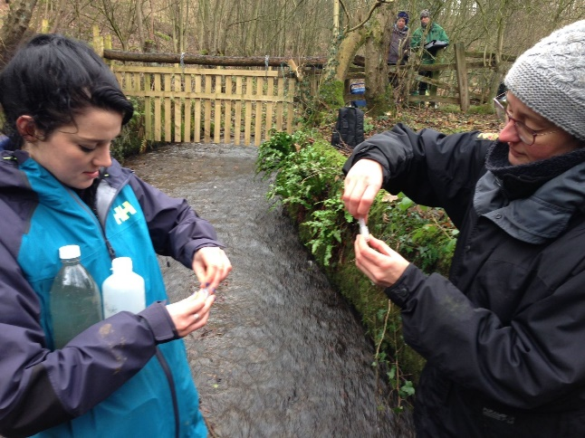
- Steering committee finalised work programme on the main themes;
- We carried out an initial chemical and biological survey of six sites on Town and Back Becks showing that the main source of water pollution came from runoff from housing estates;
- With YDRT we received a £20,000 grant from the Wharfe Flood Partnership to study flooding in the village, help to prepare for future floods and develop plans to reduce flooding and its impact in the longer term;
- With the help of Simon Johnston from the Environment Agency we set up a river level recorder on Lumb Beck;
- We set up informal working groups with residents of Saw Mill and Sidebeck;
- Helen Saunders was appointed as Assistant Project Officer, employed by YDRT and working on the 4Becks project 30% of her time;
- We conducted a village questionnaire on flooding using Survey Monkey and house to house visits by Beck Stewards, resulting in over 60 returns.
2019 Plans
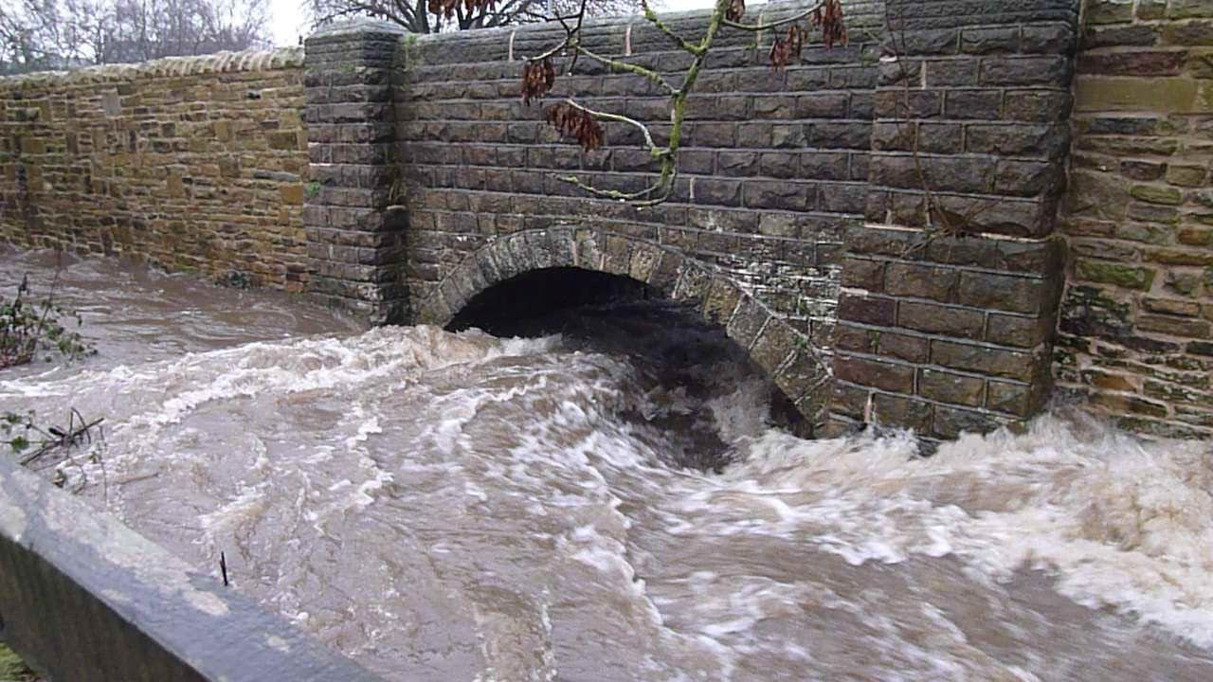
- Continue managing the4Becks project together with other steering committee members, meeting monthly in the Methodist Chapel;
- Continue building the Beck Stewards’ programme involving regular meetings, training sessions, field survey sessions and litter picking co-ordinated by Jessica Penrose;
- Work through the flood grant tasks including:
  - a comprehensive water quality survey of all four becks;
  - a 4 becks web page on the Environment Group website;
  - set up computer mapping of the catchments;
  - organise three town meetings on flooding, water quality and biodiversity;
  - survey beck pipes, barriers, springs;
  - design one or more beck walks linking points of interest;
  - assess potential for retrofitting Sustainable urban drainage systems (SuDS);
  - assess potential for Natural Flood Management (NFM);
  - produce flood risk management report for the village;
- Conduct ACS Speaker meeting on June 20th 2019;
- Seek follow-on funding to implement proposals.
Zero carbon Addingham
There is an increasingly urgent need to act locally to tackle climate change by reducing carbon emissions in the village, encouraging householders, businesses and community organisations to introduce further energy efficiency measures, and to increase the use of renewable energy.
2018 Achievements:
- Recruited new members to the energy sub-group, now called “Zero carbon Addingham”;
- Launched ideas from the group at the Environment Weekend including the use of LEDs, installing solar panels and signing-up to the carbon footprint calculator on the WWF website;
- Joined Climate Action Ilkley with Rick Battarbee as committee member;
- Agreed an agenda to:
  - Promote solar panels, exploring the possibility of installing panels on the Primary School roof;
  - Promote energy efficiency on public buildings;
  - Promote the use of the WWF carbon footprint website to encourage residents to reduce their footprint. 25 residents have submitted data so far. Their average footprint is slightly higher than the national average of 10.5 tonnes per year;
  - Explore possibility of installing charging points for electric vehicles in village car parks;
  - Raise awareness and inform the Parish Council of our agenda.
2019 Plans
- Engage with the Primary School community on energy efficiency and renewable energy issues and design a solar panel scheme for the school to consider;
- Design a solar panel demonstration to inform Primary School children and use on Environment Weekend (Day One);
- Encourage owners of public buildings and businesses to become more energy efficient by providing advice and by encouraging uptake of energy performance assessments;
- Increase the number of residents measuring their carbon footprints, calculate village averages and provide feedback to residents;
- Explore possibility of installing EV charge points with all village pubs, St Peter’s Church, the Memorial Hall, Golf Club and other organisations with car parks;
- Promote the use of E-bikes.
A war on plastic pollution and zero waste
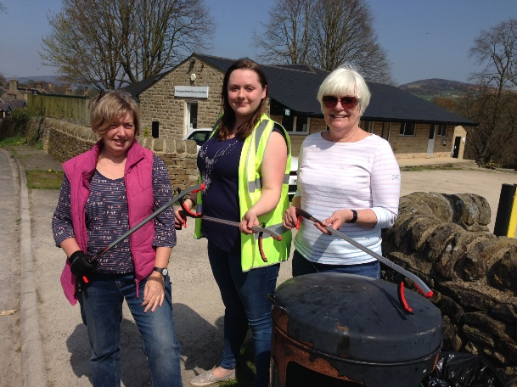
Our aim in 2018 was to create a team of volunteer litter-pickers to patrol our side streets, paths and open spaces, helping village lengthsman Richard Mulligan, and start a campaign in the village to encourage less plastic use and more re-cycling. Plastic pollution is not just in the ocean – it’s everywhere!
2018 Achievements
- Created a team of six litter picking wardens to keep green spaces clean;
- Created a team of 20 beck stewards to remove litter from the becks as well as take part in the 4Becks project (see below);
- Joined the Yorkshire Water water bottle Refill scheme, with three village outlets (The Swan, Ginger Plum and the Sandwich Shop) signed up;
- Used Facebook to raise awareness;
- Corresponded with Rowlands Pharmacy headquarters to ask for change in policy over plastic bags used for prescriptions;
- Supported the new Ilkley-based “Wharfedale tackles plastic” group https://www.facebook.com/WharfedaleTP/
2019 Plans
- Continue with litter picking in our becks and green spaces as 2018;
- Expand the Refill scheme by registering more outlets;
- Develop a Zero Waste project working with other groups in the village to help reduce use of plastic and reduce waste, exploring potential to join forces with Totally Locally.
Working with young people
Our plans in 2018 were to continue working with others in the village especially with our younger members in the Scouts, Cubs, Guides, Beavers and Brownie groups, to enthuse them about nature, help them to learn how nature works, teach them how to identify our common plants and animals and help them grow up enjoying and respecting the natural environment.
2018 Achievements
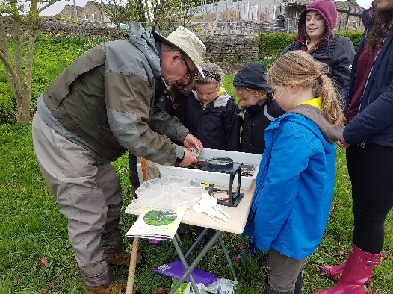
- Hedgehog project by Gill Battarbee with First Brownies (Gill Moon);
- Beck invertebrate demonstration by Steve Cheetham with Second Brownies (Jane Winter);
- Yellow rattle seed sowing in Church Field with Second Brownies (Jane Winter);
- Hedge planting in the Memorial Hall Field and at the back of the Scout Hut with the Cubs (Maz Jennings and Ruth Nottage);
- Balsam bashing at sites on the Moorside with the Scouts (Paul Jennings);
- Green space design with the Guides (Natasha Harrison, Jan Hindle and Gill Battarbee);
- Path creation by AEG volunteers to access Back Beck for the Primary School (Hilary Cave).
2019 Plans
- Second Brownies: Continue wildflower project in Church Field, and add a bumble bee project;
- Cubs: Continue hedge planting project behind the Scout Hut;
- Scouts: Continue balsam bashing and start wildflower/wildlife project at the back of the Scout Hut;
- Guides: Follow up on Green Spaces design;
- Primary School: Continue working with the Primary school creating wildlife habitats within the school grounds, exploring installation of solar panels and SuDS and providing curriculum support;
- Explore possibility of creating a new young persons eco-group in the village, building on work with the younger groups above in an attempt to create a cadre of secondary school age youngsters. Idea to be discussed with Debs Griffiths.
Volunteering
In 2018 we planned to bring more structure into our volunteering by establishing Saturday mornings (between 10 am and 12 noon) as our main weekly focus for fieldwork. We also planned to introduce a seminar programme to explain what we are doing to the wider village community.

2018 Achievements
- Developed a more or less continuous programme of practical work in the community on Saturday mornings between 10 and 12 noon;
- Recruited six litter wardens to take care of our Green Spaces;
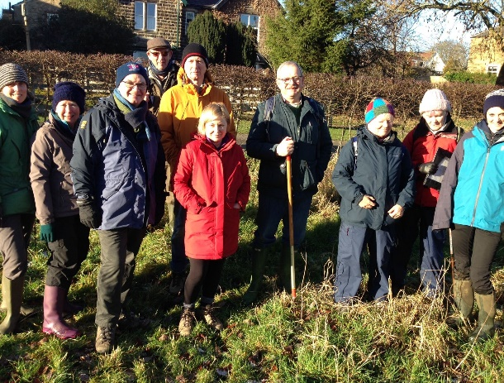
- Recruited 15 Beck Stewards to clean the becks and help deliver the 4 Becks project agenda;
- Recruited 20 Wildflower planters to grow wildflowers from seed in pots at home;
- Attracted more than 50 members to turn out at least once during the year to take part in working parties, grass raking, seed sowing, seedling transplanting, dock leaf digging, balsam bashing, bluebell planting, culvert clearing etc;
- Benefited from the support of Fin Procter as Duke of Edinburgh Gold Award student;
- Set-up a Google calendar on the website to provide advance notice of volunteering jobs and other activities;
- Started a register to record the hours contributed by volunteers.
2019 Plans
- Continue the Saturday morning programme;
- Continue the litter warden scheme;
- Continue the beck steward scheme;
- Continue wildflower seed growing;
- Recruit Duke of Edinburgh award students. James Mann (Gold) and Robert Mann (Silver) already recruited;
- Continue range of activities as for 2018;
- Develop new activities in association with the Primary School including fence removal, habitat restoration, wildlife monitoring and curriculum support;
- Continue to record volunteer names and hours to use as in-kind funding for grant applications etc.
Walks
In 2017 Don Barrett and Jonathan White embarked on a programme of updating old village walks and creating new ones. In 2018 they planned to finish the process. Several new walks (some short, some long) were to be trialled, tested and made available.
2018 Achievements
- Publication of book of village walks by Don Barrett, available from Amazon, the Post Office or Steve Lloyd (Civic Society);
- Continued to sell the Sailor and Southfield walk leaflet (30 p);
- Designed short village walks for the two editions of the Village Newsletter;
- Designed guided walk for the Environment Day on June 30th. About 40 people participated.

2019 Plans
- Design new walk for the 2019 spring village newsletter to be used as the basis of the Environment Weekend walk. The route will follow the Hollow Lane, The Street, Cat Steps, Small Bank, Gatecroft and Lumb Ghyll Wood (Rick Battarbee);
- Design new walk or walks focussing on the becks, part of the 4Becks Project (Beck Stewards);
- Help the Civic Society design signage for a view-point to be created at the bottom of Old Mill Lane (view point suggested by Debs Griffiths). The site can be the end or starting point of the Becks walk;
- Design a local geology trail up to Addingham Edge (Rick Battarbee and Will Varley).
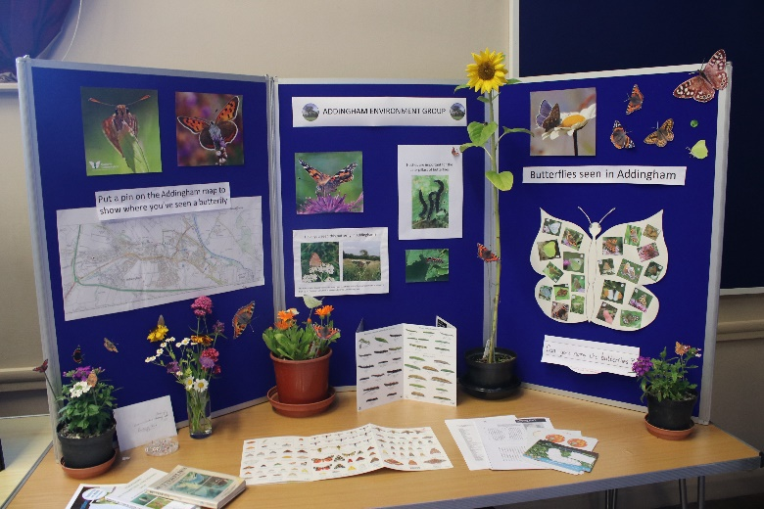
Environment Weekend, June 30th/July 1st 2018
Our Environment Weekend for 2018 was planned by Gill Battarbee to include displays and activities on the Saturday morning in the Memorial Hall and a guided environment walk on Sunday July 1st.
2018 Achievements
- A very successful event was held in the Memorial Hall on Day 1 including many external exhibitors, a demonstration electric car and the Yorkshire Dales Rivers Trust mobile classroom. It was attended by over 200 people;
- A successful afternoon on Day 2 with two well-attended conducted walks (see above).
2019 Plans
- Repeat the format of 2018 but with Day 1 (Saturday, May 18th) staying open into the afternoon to allow residents unable to visit in the morning to attend;
- Repeat the format of 2018 for the Day 2 (Sunday, May 19th) afternoon walk again with two groups;
- Explore the possibility of finishing the walk at Judith Wallbank’s farm.
Membership, comms and outreach
Our aim in 2018 was to continue building membership and use social media and other publicity methods to promote our activities.
2018 Achievements
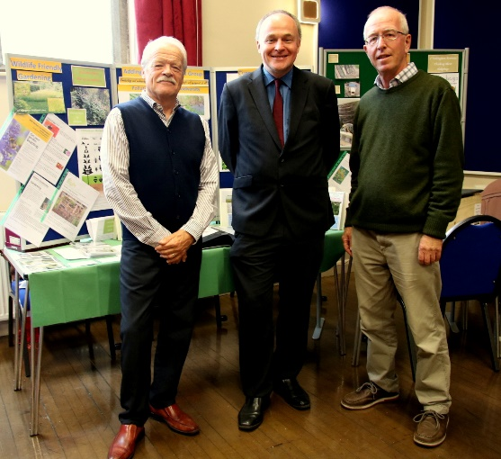
- Built a membership (email circulation list) of over 150 Addingham residents;
- We have over 200 followers on Facebook;
- We have over 50 followers on Twitter;
- We have designed a new website, courtesy of Don Barrett, using Word Press, that allows Rick Battarbee to add and edit content;
- Those members who volunteer on Saturday mornings and other times were asked to join the Civic Society to benefit from ACS’ public liability insurance cover. Almost all have done so, bringing ca. 20 additional members to the Society;
- Activities, especially the Environment Weekend, reported in the Ilkley Gazette;
- Talks to local organisations including Ilkley U3A, Craven U3A, Wild Trout Trust, Dales to Vale Network, Wharfedale Naturalists Society, Craven Naturalists and the Methodist Church were given by Rick Battarbee.
2019 Plans
- Continue adding to the membership list (aiming for a target of 200);
- Continue encouraging members to join the Civic Society;
- Continue posting on Facebook and aim for 250 followers;
- Continue tweeting and increase number of followers (target 100);
- Update website and build a stronger web presence presenting current activities and building up information content;
- Continue giving local talks: e.g. to Upper Wharfedale Field Society, Craven U3A, Yorkshire Dales Society;
- Take advantage of the new Old School Hub not only for meetings but for exhibitions, training sessions and seminars;
- Consider setting up a group of Ambassadors who might be enlisted to distribute post cards to every household in the village promoting e.g. our carbon footprint, wildflower/pollinator projects.

