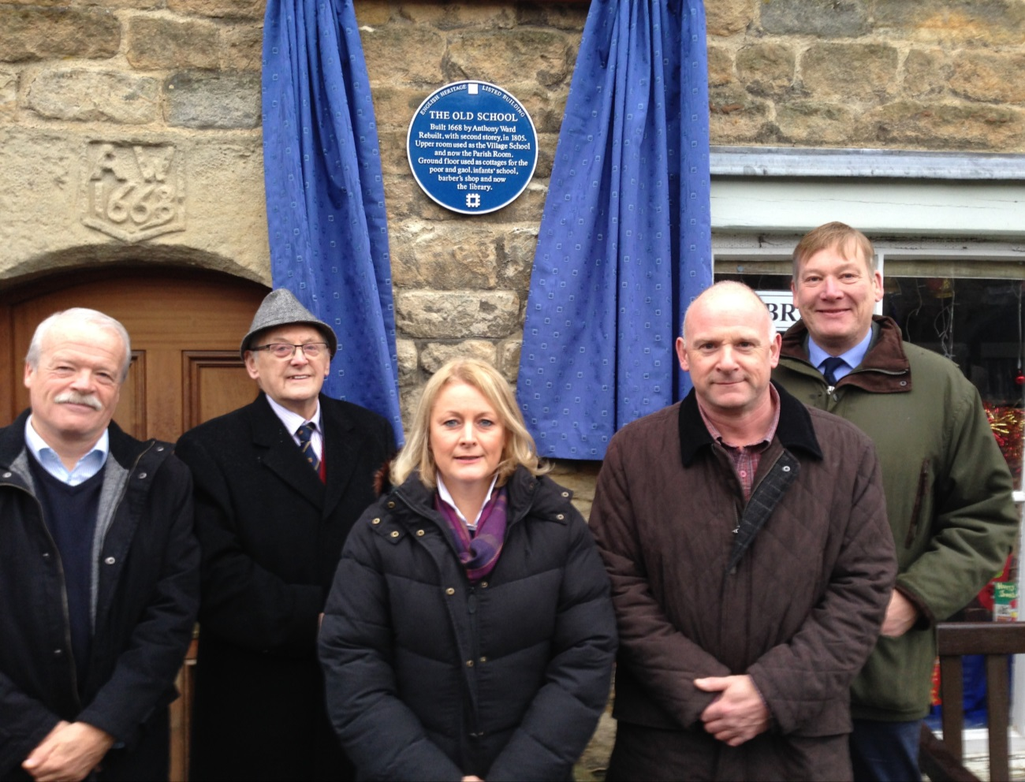
Un-veiling of the Old School Blue Plaque - Saturday 3rd January 2015
Left to Right: Jim Robinson, Chairman of Addingham Civic Society; BMDC Deputy Lord Mayor- Roger L’Aime; Catherine Coates, Chair- Addingham Parish Council; John Mawson, Vice-Chair - Addingham Parish Council and Kris Hopkins MP for Keighley &Ilkley
Addingham Parish Council were pleased to see the un-veiling of a new Heritage Blue Plaque, on The Old School on Saturday 3rd January 2015, by The Deputy Lord Mayor, Councillor Roger L’Aime
They invited along representatives of the Addingham Civic Society who had helped to design and source the high quality plaque which has pride of place on the front of the building.

Chairman Catherine Coates noted the historical significance and importance of the building to the Village, noting its varied past uses which include Village School, local shop, meeting room and even at one time a local “lock-up” /Gaol.

Today the building is used as a Community Library in the downstairs room; which is run by a dedicated group of volunteers who are supported by Bradford MDC in providing a library service. The upstairs room is still used for community group meetings and as the regular meeting room for the Parish Council.

Future plans for the building are being investigated by the Council, along with Library Trustees and Mr. K Appleyard; as the Council hope to secure grant funding for building improvements and refurbishment which will secure the long term viability of this important village asset.

